fhe Official Publication of ALOA—An International Association of Security Professionals



gh security

*:h\*\*\*\*\*\*\*\*\*\*\*\*\*\*\*\*\*\**2-DIGIT 303 Breck H. Camp CML PO Box 47070 Atlanta GA 30362-0070

lull,II **IIhILmMIL.IL.L.III.J.JII 1,11**

High Security

The New Medeco3 Imp

Plus: Building the Perfect ALOA Va

Fearsome Maximus and a Diebold

Tryout Keys on the Ford Explorer, Loc

Part 1 and more

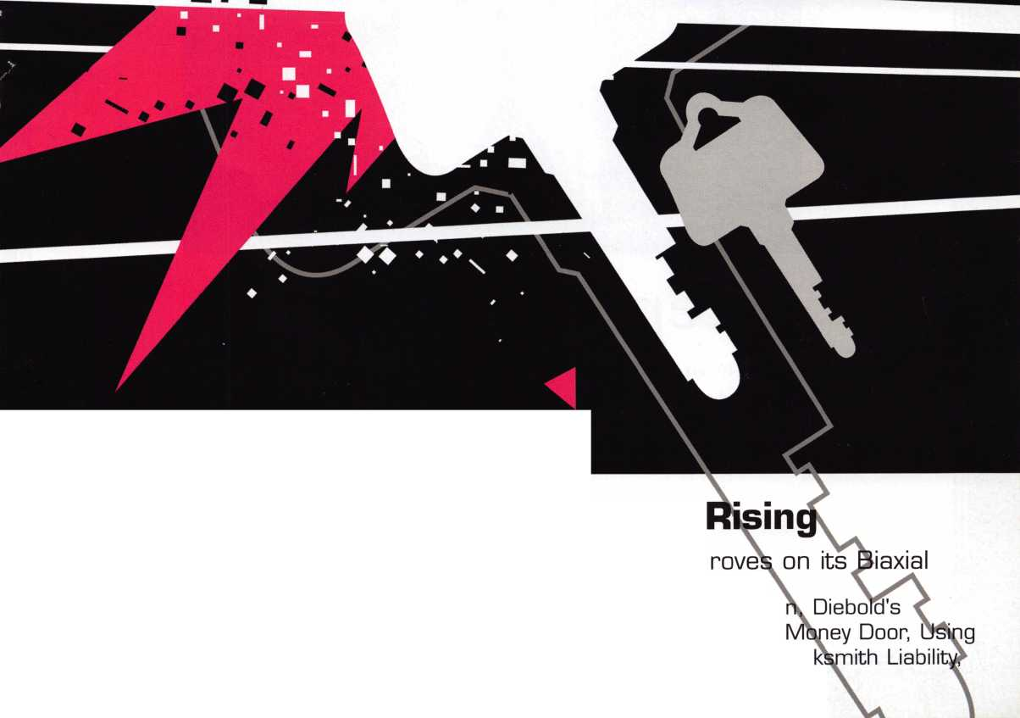

Keep Your Day Job

Come to Las Vegas and invest in your future as a security professional.

Discover classes, workshops, and exhibits that will keep you competitive in today’s marketplace.  
Las Vegas Hilton/Las Vegas Convention Center • July 14-20, 2003

The only gamble is staying home

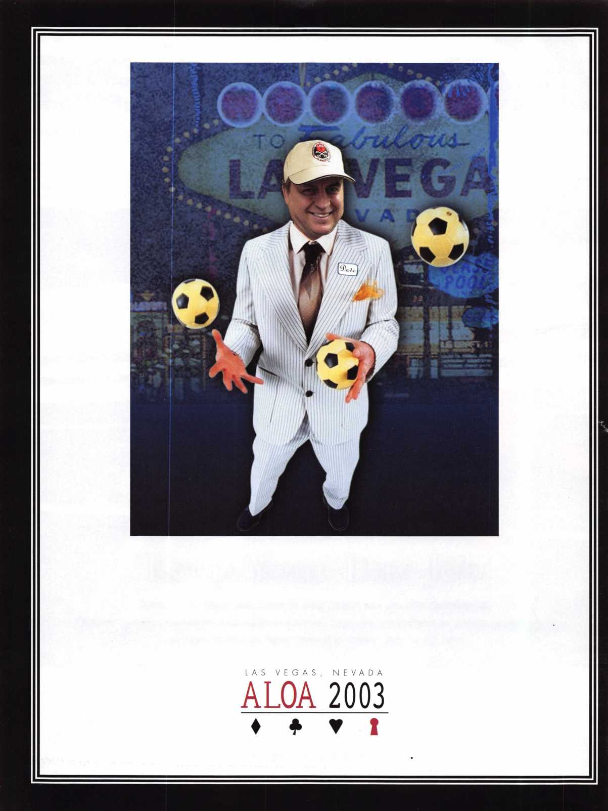

CEN.XXXXXX

kaba koupon

| '*ard Stop Refresh Home

The Kaba Mas Dealer Network is the second phase of our new distribution channel that includes sales support, technical support services, product development and technical training classes. The first step was to create a network of wholesalers - the Wholesale Network - who all received extensive in-house training on all of our products and are supported by our internal and external sales team. By providing our distribution channel with education and sales support, they are better equipped to service your product needs.

**KABA** **The Brand for Safe Locks**

**\a/\a/\a/ Ira ha-mac rnm**

A Member of the Kaba Group

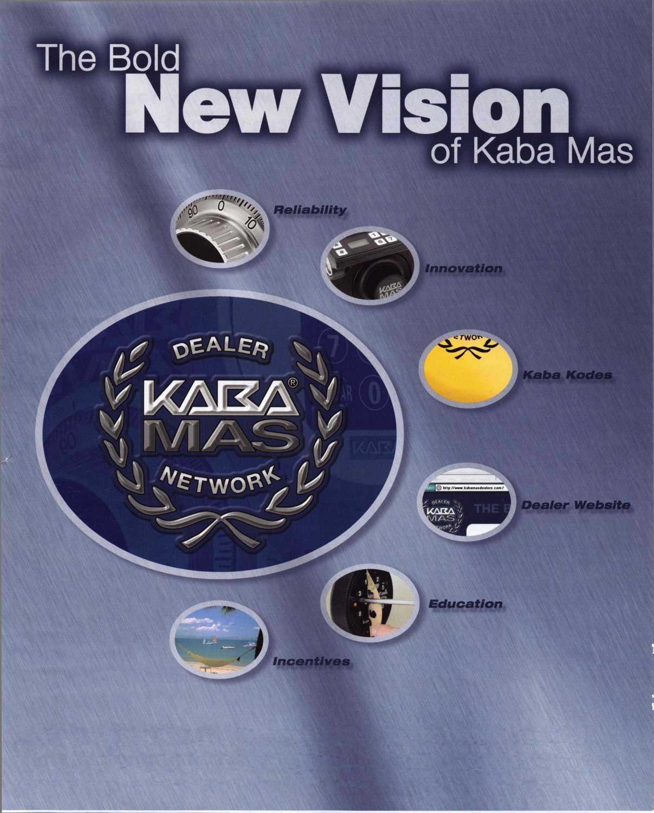

**Your Key to Unlocking** % **„ Ford/Mazda**

m -fc ■- 4^ O*.

**Transponder**

^fitsai^

for more information visit

**[www.hickok-inc.com](http://www.hickok-inc.com)**

**' You're never on your own...**

**Toll Free Tech Support**

**1**-**800**-**342-5080**

"I've lost my Taurus keys...  
can you make a new set?"

How much of your money have you sent to the / local Ford dealer?



8008LA New Generation STAR

Use the Ford factory tool to  
program transponder keys for  
ALL Ford/Mazda vehicles.

Keep the money in your pocket!

NGS

Complete  
Ford/Mazda  
transponder  
coverage

PLUS the

ability to  
clear ALL  
Diagnostic

Service Codes

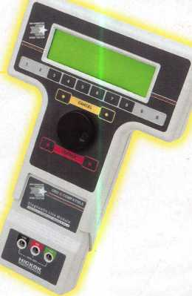

Say "YES" to  
$100 phone calls



HICKOK

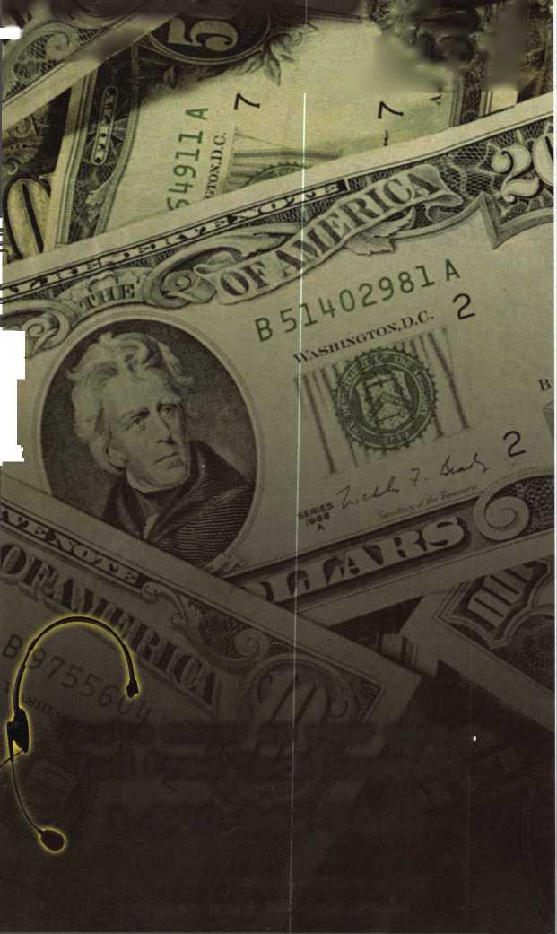

Why do we call it High Security anyway?

When high security locks were first introduced over 40 years ago, the distinction in the name was made purposely to distinguish the leap in quality between these new products - which provided increased pick resistance, physical attack and patented key control - and the traditional locks, whose basic design had been around since Linus Yale, Jr. patented the pin tumbler locks in 1851, which couldn't stand up to a surreptitious or physical attack nearly as well.

But as we know all too well, times change. Today's market doesn't demand a mere distinc­tion between two types of lock products. Our customers are busy people who simply do not have the knowledge that we have. They require that we provide them with the proper information so that they can make good, sound purchasing decisions based on the knowl­edge that we provide for them, their companies and their families. High security key con­trol products have ceased to be some crazy new innovation. On the contrary, they are the current standard (UL 437, in fact), for an acceptable level of security in our industry. I would consider it a failure if I sold anything less than a patented key control, high security lock to any customer; it would mean I failed to adequately communicate the solution for their security needs to them.

So the introduction of the concept is over. Patented Key Control, High Security should be considered the standard security in today's day and age. We as ALOA Professional Lock­smiths have a responsibility to move this industry forward, and one of the best ways to do it is to insist that your customers use high security (read "standard security") products.

Thanks,

Randy Simpson, CML

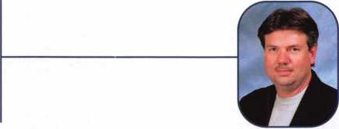

Keynotes • June 2003

AlOA continues to provide you with this  
and other great benefits and services!

Get What's Coming To You

Need information in a hurry? Use ALOA’s Fax On Demand service.

310**-**575-5074

Just call 310-575-5074 and receive:

1. ALOA Index of Documents
2. Becoming a Locksmith (Ipg)
3. Locksmith Career Summary (3pg)
4. Locksmith School List (2pg)
5. ACE Class Schedule (8pg)
6. Certification !nformation(3pg)
7. PRP Category List (1 pg)
8. ALOA Membership Application(2pg)
9. ALOA List of Benefits (Ipg)
10. Scholarship Application Form (Ipg)
11. ALOA Video Library Order Form (Ipg)
12. ALOA Membership Items Order Form (Ipg)
13. Safe & Vault Technicians Association Member  
    Application/Subscription Form (2pg)
14. ALOA Chapter Roster (3pg)
15. Legislative Action Network (2pg)
16. Legislative Action Network Newsletters (Ipg)
17. Various State Laws (lOpg)
18. Industry Position Pager (Ipg)
19. Current Legislative Action Network  
    Newsletters (Ipg)
20. Board of Directors Nomination Form (2pg)
21. ALOA Convention Registration
22. ALOA Board Expense Reimbursement &  
    Request Form

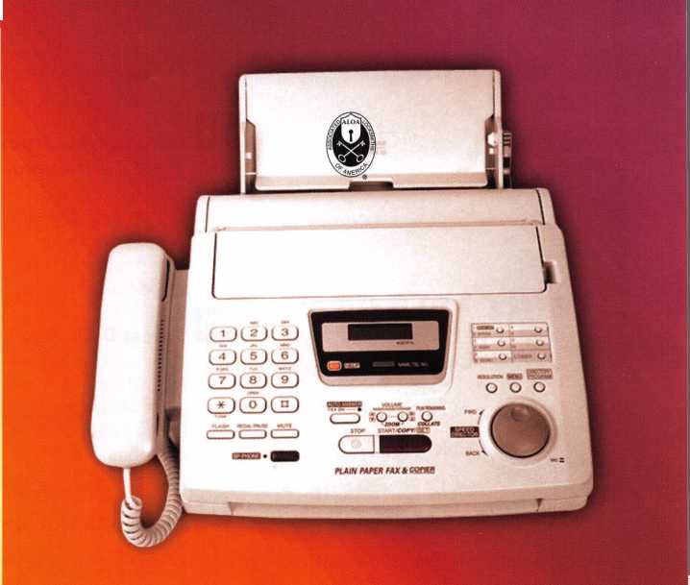

f e

t

u

r

e

a

**departments**

Executive 5

Applicants 6

Calendar 8

Core 10

Legislative Update 38

Classifieds 40

Associate

Members 42

Back Page 44

Institutional

12

Cover Story - High Security Rising bx Greg Perry, cml,cps

Medeco3 is here and no new pin kits or key machines are needed. (Thank  
you, Medeco!) Medeco has developed a new product to address the impend-  
ing patent expiration of Biaxial in July, 2005. Let's take a first look at it.



The Ultimate Weapon in Locksmithing  
A Killer Service Truck by Ed woods, crl,cps

First things first: Let's thank the ALOA Scholarship Foundation for the great door  
prize at the 2002 convention. Yeah, this is the van they GAVE away last year  
as a door prize. Also, let me thank KNAACK-WEATFHERGAURD for the dona-  
tion of the interior and cabinets. Don Rule, CML, from ALOA and Jack Daniels  
from KNAACK both worked with me to transform the van and interior into a  
killer service truck. First, we bumped the E-150 up to and E-350 Super Cargo  
van. FHere's how we filled it out.

**22**

Automotive: Tryout Keys and the

2002 Ford Explorer By Red Howell, RL

There are several different approaches or options for making a key for this vehicle. The following lists a couple of options when making a key: impression- ing, disassembly or using tryout keys. Impressioning causes stress on the lock and disassembly is time consuming and increases the risk of damage. Let's take a look at using tryout keys instead.

**24**

Safes: Diebold's Fearsome Maximus

By Greg Perry, CML, CPS

It's a name that strikes fear into many safecrackers' heart. I spoke with a Diebold technician from central California who said he only knew of one man in the whole country who could open a Maximus, SAVTA president Skip Eckert, CML. I can think of many others, but the Diebold technician gives you an idea of how difficult some feel this safe might be to open if something goes wrong.

**28**

Locksmith Liability Part 1 By Marc Tobias

The following two-part series summarizes potential liability issues that can con­front the locksmith. Part I concentrates on general liability associated with more traditional tasks.

**32**

Diebold MONEY COMPARTMENT DOOR

By Merritt Perkins, RL

This article examines the door to the money compartment inside a Diebold bur­glary-resistant safe. The door is 6 inches wide by 12 1/2 inches high with the dial of the combination lock near the top. In the center is a key operated lever tumbler lock. Let's take a look at it.

Visit our website at [www.aloa.or](http://www.aloa.or)



executive

Volume 49, Issue 6

Additional contact information for the ALOA Board and most Keynotes authors is  
available through "Locksmith Search'" on the ALOA Web site- [www.aloa.org](http://www.aloa.org) or by  
contacting the ALOA office at 3003 Live Oak Street; Dallas, TX 75204; (800)532-2562;  
FAX (214)827-1810; e-mail [aloa@aloa.org](mailto:aloa@aloa.org).

Editor

Jim DeSimone [editor@aloa.org](mailto:editor@aloa.org)

Technical Editor

David Lowell, CML, CMST [david@aloa.org](mailto:david@aloa.org)

Editorial Advisor

John D. Cannon, CML [jdcannon@worldnet.att.net](mailto:jdcannon@worldnet.att.net)

Art Director

Betty Henderson [betty@aloa.org](mailto:betty@aloa.org)

Advertising Sales

Kim Hammond voice: 817-645-6778

Fax: 817-645-7599 e-mail: [adsales@aloa.org](mailto:adsales@aloa.org)

Executive Director

Charles W. Gibson, Jr., CAE [charlie@aloa.org](mailto:charlie@aloa.org)

Convention & Meetings Manager

Jo Anne Mims [joanne@aloa.org](mailto:joanne@aloa.org)

PRP/Education Manager

David Lowell, CML, CMST [david@aloa.org](mailto:david@aloa.org)

Operations/Membership Manager

Mary May [mary@aloa.org](mailto:mary@aloa.org)

Government Relations Manager

Paul Kanitra [paul@aloa.org](mailto:paul@aloa.org)

IT Operations Manager

Greg Jackson [greg@aloa.org](mailto:greg@aloa.org)

Comptroller Kathy J. Romo

Membership Coordinator Shelly Jett

Convention & Meetings Assistant Karen Lyons

PRP/Education Coordinator Janelle Ramirez

Accounting Coordinator Stephanie Brothers

Mail Room Coordinator Kevin Wesley

Receptionist Shawn Alvear

Contributors

Jerome Andrews, CML  
Paul Chandler, CRL  
Claire Cohen, CML  
Brian Costley, CML, CMST  
Ray D'Adamo, CML

Sal Dulcamaro, CML Billy Edwards, CML Dan Graffeo, CRL,CMST AJ. Hoffman, CML Jeff Nunberg, CML, CMST

Mike Oehlert, CPL, CPS Randy Simpson, CML Robert Stafford, CML Dave Thielen, CML Greg Perry, CML,CPS

Tom Seroogy Charles Stephenson, CPS Dennis Watanabe, CML, CMST

**Mission Statement:** The Associated Locksmiths of America, Inc. is dedicated to enhancing the professionalism, education and ethics among locksmiths and those in related sectors of the physical security industry. With approximately 10,000 members in the United States, Canada and the freeworld, ALOA is poised to help members obtain the knowledge, the strength, and the confidence to perform their role in the physical security field with pride and dignity. But it is only through active involvement and participation that ALOA can fully achieve its potential—and can help members to achieve theirs.

**Policies:** Keynotes® is the official publication of the Associated Locksmiths of America, Inc. (ALOA). Keynotes® acts as a moderator without approving, disapproving, or guaranteeing the validity or accuracy of any data, claim, or opinion appearing under a byline or obtained or quoted from an acknowl­edged source. The opinions expressed by the authors do not necessarily reflect the official views of ALOA. Also, appearance of advertisements and new products or service information does not constitute an endorsement of products or services featured by the Association. The Association does not accept responsibility for the inaccuracy of any data, claim, or opinion appearing in this publication, due to typographical errors on the part of the authors, Association staff or its agents.

**Editor's Note:** This publication is designed to provide accurate and authoritative information in regard to the subject matter covered. It is provided and disseminated with the understanding that the publisher is not engaged in rendering legal or other professional services. If legal advice and other expert assistance is required, the services of a competent professional should be sought.

**Authors' Payment:** Payment for eligible submissions to Keynotes will be based on the following criteria: topic, time spent and past contributions. Authors who regularly submit to Keynotes® are generally paid a higher rate. The latter is especially true of authors who write to fit specific editorial needs and submit said copy by Keynotes® deadlines. As a general guideline: Average payment for a 750 word, business or light' technical article would be $200. Payment for a 1500 word article involving significantly higher time and research efforts would be $400.

Payment will not be offered for articles submitted by ALOA employees or members of the ALOA Board of Directors (unless material is of a technical nature), nor for articles submitted by a company that promote that company's products or services. ALOA reserves the right not to pay for articles sub­mitted by an individual(s) that promote a particular company's products or services.

**Disclaimer:** The Associated Locksmiths of America, Inc., (ALOA), reserves the right to refuse any article for any reason. Additionally, ALOA reserves the right to edit, amend or modify any article submitted for publication in order to preserve technical accuracy, clarity, fairness or grammatical cor­rectness. ALOA will make the best efforts to notify the author of any changes. The extent of ALOA's liability for any article or information contained therein will be a notice of correction or retraction in the next possible issue.

Keynotes® (ISSN 0277 0792) is published monthly except for the combined June/July issue by The Associated Locksmiths of America, Inc., 3003 Live Oak St., Dallas, TX 75204-6186. Telephone: (214) 827-1701; FAX (214) 827-1810; e-mail [aloa@aloa.org](mailto:aloa@aloa.org). Subscription rates for members—$15.00 per year. Business class postage paid at Dallas, Texas. POSTMASTER: Send address changes to: Keynotes, 3003 Live Oak St., Dallas, TX 75204-6186. © Copyright 2003, All rights reserved. No part of the contents may be reproduced or reprinted in any form without prior written permission of the publisher.

President

Randy Simpson, CML

1. 780-7026 [president@aioa.org](mailto:president@aioa.org)

Secretary

John D. Cannon, CML  
(703) 960-6413  
secreta ry@a loa. org

Directors, Northeast

Robert E. Mock  
(856) 863-0710

[nedirector@aloa.org](mailto:nedirector@aloa.org)

Peter Sarailian, CRL  
(973)890-9797  
[nedirector@aloa.org](mailto:nedirector@aloa.org)

William L. Young, CML  
(610) 647-5042  
[nedirector@aloa.org](mailto:nedirector@aloa.org)

Directors, Southeast

Vincent Formon, CML, CPS  
(901) 324-2910  
sed i rector@a!oa. org

Donald E. Rule, CML  
(662) 324-2658  
sedirector@aloa .org

Directors, North Central

Mark E. Blum, CML, CPS  
(517) 482-5809  
ncdirector@aloa. org

John Soderland, CML, CMST  
(414) 327-5625  
prolock@a loa. com

Director, South Central

CD Lipscomb, CML, CPS  
(903)874-3522  
[scdirector@aloa.org](mailto:scdirector@aloa.org)

Directors, Southwest

Gordon R. Racine, CML  
(719) 384-4707  
swd i rector@a loa. org

Julie McCluney, CRL

1. 636-5652 swdirector@aloa .org

Director, Northwest

Scott L. Henke, CPL, CPS  
(907) 248-3785  
n wd i recfor@aloa. org

Director, European

Hans Mejlshede, CML  
(453)539-3939  
eurdirector@aloa .org

Director, Asian

JoeJ. Lee, CRL  
(215)289-2404  
[asiandirector@aloa.org](mailto:asiandirector@aloa.org)

Director, Associate

Paul M. Justen  
(800)333-6953  
[asdirector@aloa.org](mailto:asdirector@aloa.org)

Trustees

trustees@aloa. org

JohnJ. Greenan, CML, CPS  
(773) 486.2030

Dallas Brooks  
(334) 826-8990

David M. Lowell, CML, CMST  
(800) 532-2562

Past Presidents

1999-2001 John Greenan, CML, CPS  
1997-1999 Dallas C. Brooks  
1995-1997 David Lowell, CML, CMST  
1993-1995 Breck Camp, CML  
1991-1993 Henry Printz, CML  
1989-1991 Evelyn Wersonick, CML, CPS  
1987-1989 Leonard Passarello, CPL  
1985-1987 Joe Jackman, CML  
1983-1985 Stanley Haney, CPL  
1981-1983 Louis LaGreco, CPL  
1979*1981 John Kerr, RL  
1977-1979 Clifford Cox, CML  
1974-1977 Charles Hefherington  
1972-1974 Gene Laughridge  
197G1972 William Dutcher, RL  
1968-1970 Constant Maffey, RL  
1966-1968 Harold Edelstein, RL  
1964-1966 William Meacham  
1962-1964 Robert Rackliffe, CPL  
19601962 Edwin Toepfer, RL  
1956-1960 Ernest Johannesen



Keynotes • June 2003



Bentonville

Eric Elander

Forrest City

Wayde E. Thomas

Jonesboro

Britt Cooper

Sponsor: Vincent L. Formon CML, CPS

Mesa

Michael P. Casey Tim McHenry

Sponsor: William Lee CRL Phoenix

Douglas Bellinger

Sponsor: Nicholas A. Monaco CRL

CA

Anaheim

Casey S. Pendlebury

Sponsor: Daniel S. Enriquez CRL Cathedral City

Jason Rodgers

Chula Vista

Tony Gudino

Lompoc

Christian M. Villa

Sponsor: John H. Linn Lone Pine

Robert Hayner

Sponsor: Gregory L. Perry CML, CPS Los Alamitos

Gene Gednov

Sponsor: Stanley C. Ross Paradise

Mike Barker

Sponsor: Ralph O. Skytte Patterson

Anthony Tossounian Rancho Cucamonga Riley A. Gale

Sponsor: Gregory L. Perry CML, CPS Salinas

Ronnie G. Rehn

Sponsor: John W. Thompson CPL San Francisco

Hazel L. Betsey

San Leandro

Kurt Ditmer

Van Nuys

Pamela Becker

Yuba City

Bradley J. Williams

CO

Aurora

Nicola G. Cannao

Sponsor: Dean I. Carpenter

Rolland L. Camp

Sponsor: Kent A. Smith CML Colorado Springs

Eric Morgan

Sponsor: Thomas A. Adams CPL Edwards

Dawn R. Riddle

Littleton

Brad W. Walter CRL

Longmont

Allen Elder

Trinidad

James McCoy

Sponsor: John L. Shandy CML Vail

Kurt Batchelder

Wellington

Daniel Caufman CRL

CT

Salem

John L. Carboni

Waterford

Peter Doherty

FL

Miami

Garry Bowman Jason D. Hertzberg

Sponsor: Jay J. Wiener Tallahassee

Dennis Moseley Robert J. Lilly

Tampa

Catherine Van Orden

Sponsor: Samuel A. Stanford Vero Beach

Sherman Wilder

Sponsor: George E. Bloomer

*GA*

Decatur

Kenneth G. Young

Plainville

Greg L. Womack

IL

Areola

Timothy Romine

Sponsor: Werner G. Rossmann Chicago

Andrew K. Meshenberg

Sponsor: Steven B. Clare Metropolis

Ed Hamm

Sponsor: Clifford D. Lipscomb CML, CPS Quincy

Charles R. Zanger

Sponsor: Michael A. Zanger

IN

Fort Wayne

Michael Wiegmann

Indianapolis

Gloria J. Murff

Sponsor: Jim Williams CRL

Berea

Chris A. Frontz

Sponsor: Dan Billheimer CRL

Dawson Springs Kenneth McBride

Sponsor: Michael A. Pezzuti Sr

LA

New Orleans

Julie Savoy

Sponsor: Diane M. Foto CRL

Nina Rojas

Sponsor: Diane M. Foto CRL

MA

Boston

Michael Medice

Sponsor: David M. Troiano

Cambridge

David Burns

Sponsor: David M. Troiano Dorchester

Eric N. Anderson

Sponsor: David M. Troiano Melrose

Barbara Baker

Sponsor: David M. Troiano Peabody

William D. Whitney

Sponsor: David M. Troiano Saugus

Thomas A. Lima Jr

Sponsor: David M. Troiano Tyngsboro

Sally S. Marcheterre

Sponsor: David M. Troiano

MD

Hyattsville Keith Howell

Sponsor: Philip A. Rovenolt CPL Lisbon

William R. Hoyle

Sponsor: Robert W. Duman Sr, CML Rockville

Al Moran

Detroit

Larry Walker

Sponsor: Maurice R. Horne CML

MN

Hastings

Patrick D. Moseng

Sponsor: Michael J. Foty CPL

MO

Rolla

Ronnie R. Henson

Sponsor: Maurice H. Reagan

Canton

Tracy Bunyard

Sponsor: Michael W. McCorkle CRL

NC

Asheville

Mark Sherron

Sponsor: Alford Sherron

Seabrook

Robert J. Barry

Sponsor: David M. Troiano

NJ

Haledon

Birgitte Hansen

Sponsor: Thomas E. Ware CML, CFL Springfield

Seth Kenter

Sponsor: Peter Sarailian CRL

NV

Sparks

Brenda Freiberger

Adams

Glenn Federman

OH

Garfield Heights

Michael Schilk

Sponsor: Mark S. Brajdich CRL

OK

Dewar

Randy E. Gregory

Enid

Dusty L. Brummitt

Owasso

Jon M. Winesburg

Sponsor: Lelia R. McNickle CPL

PA

Philadelphia

Winford Hayes Jr

Sponsor: Jimmie G. McKahan

SC

Florence

James Ard Jr

Sponsor: James C. Ard Sr

SD

Sioux Falls

David E. Schmitz

TN

Collierville

Patrick Hurley

Sponsor: Vincent L Formon CML, CPS

Knoxville

Justin Nash

Sponsor: John E. Simpson

John E. Simpson

Nashville

Joshua W. Osband

Sponsor: Chris J. Abigt

Kathy Gillingham

Sponsor: Tom G. Gillingham Jr, CML, CPS

Tullahoma

Angela Cyree

TX

Bedford

Scott E. Cook

Sponsor: John B. Arnold CML Dallas

Charles R. Brown

Garland

Leah Dremml

Sponsor: Robert H. Golden CPL

UT

Ogden

Wayne Stauffer

Sponsor: Roger C. Yost CML, CPS

VA

Buffalo Junction

James M. Childress CRL

Hampton

Robert P. Andrews

Sponsor: Brooke P. Berry CRL Leesburg

Karm Sandhu

Sponsor: Timothy F. Horton CML Lorton

Steven D. Meade

Sponsor: William J. Thorpe McLean

Matthew J. Avila

Sponsor: Timothy F Horton CML Norfolk

Steven E. Jordan

Reston

William Dranginis

Salem

Monique L. Tinnell

Sponsor: Clyde T. Roberson CML, CPS Stafford

Christopher J. Visser

WA

Castle Rock

Franklin Merritt Sr



John T. Mills RL

Sponsor: D K. Moore Appleton

Jerrold G. Antoon RL, CPP

Sponsor: Clifford D. Lipscomb CML, CPS

Chippewa Falls

Tammy Haroldson

Eau Claire

Paul C. Noll

Sponsor: John S. Dorsey CML, CPS Shawano

John H. Campbell RL

Sponsor: Clifford D. Lipscomb CML, CPS

WY

Gillette

Jon Lueras

Bermuda

Hamilton

Cathy D. Barnes

Sponsor: Dawn M. Barnes

Canada

NB Riverview

Jack Durepos

Sponsor: Marc H. Bertrand Kanata, Ontario

Mike Laeroix

London, Ontario

Gordon Schurr

Scarborough, Ontario

Ian Ray

Japan

Nagoya Aichi

Mizuno Masaru

Sponsor: Yuriko Yanai Ohgaki Gifu

Masato Horiguchi

Sponsor: Yuriko Yanai Saitama City Saitam

Imai Toshio

Sponsor: Yuriko Yanai

Taiwan

Yong Kong City Tain

ChungYu Chen

Sponsor: Qing Min Cao Yonk Kong Tainan

John Chung-Yu Chen



Rottingdean East Sussex

David Sheridan

Sponsor: Ken Dale

GB

Farnborough Hampshire

Martin Hutton

These applicants are scheduled for clearance as members of ALOA. The names are published for member review and comment within 30 days of this Keynotes issue date,  
respectively, to ensure applicants meet standards of ALOA's Code of Ethics. Protests, if any, should be addressed to the Membership Department and must be signed. Active  
Membership applicants (a) have worked in the industry two or more years. Allied Membership (AL) applicants are not locksmiths, but work in a security-related field.

Apprentice Membership (AP) applicants have worked in the industry less than two years.

Keynotes • June 2003

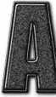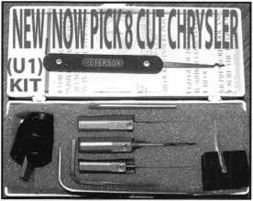

Universal Ford Flush-Mounted/Chrysler 8-Cut Ignition Removal Kit #U1 (patented)

Use this tool on all Ford flush mount ignitions, with or without side bar, large and small diameter face, all types of focus locks. With adapter, you can do virtually all Chrysler, Dodge, and Jeep 8-cut ignitions with no damage to lock. Similar kits sell for over $100.00 and only do Chrysler. Fit key and replace. In less than 5 minutes, you will have them out. Kit includes: 1 force tool (to remove face); 3 drill & arbors; 3 drill guides for all access holes; side B AR pressure tool; turn wrench; tumbler holding tool (to assemble and disassemble). No other tool needed with this kit. SFIOW SPECIAL: get free adapter for Chrysler, Dodge and Jeep with each kit. $155.00 +$6.00 S&H

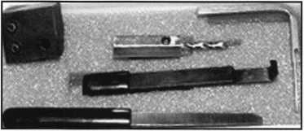

1998 Up G.M. In-Dash Ignition Removal Kit (patent 5454245)

Remove plastic ring and chrome cap in seconds. Make access hole to pick side bar. Turns cylinder to ACC position to remove lock in less than 5 minutes with no damage to lock. Your first job will pay for this kit. $70.00 + $6.00 S&H

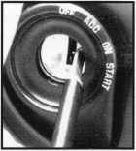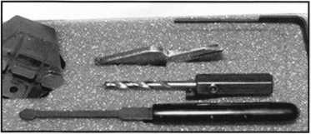

1996 Up Ford 8 Tumbler Ignition Removal Kit and Side Bar Breaker Tool

(patent 5701773)

Use force tool to turn ignition to “on” position in less than 60 seconds. To start car or for fast ignition lock removal or use kit to push side bar in, turn cylinder to “on” position for fast removal without any damage. Fit key, replace same lock. $90.00 + $6.00 S&H

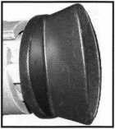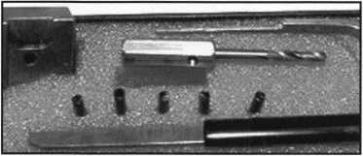

1994 Up G.M. 9 Tumbler Ignition Removal Kit (patent 5454245)

The locks have longer side bars than the older type and must be in the “on” position to remove. This kit will do that with no damage to the lock. Fit key and install same lock. Does all types, vats, mrd, top hat, module, etc. Your first job will more than pay for this kit. New with update to do module locks, blazers, suburbans, pick-ups, etc. $80.00 +$6.00 S&H

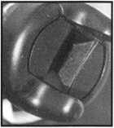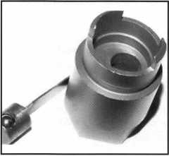

Ford “Quick-On” (patent 5454245)

Now turn all 10-cut ignition cylinders to the “on” position for fast removal-in less than 60 seconds. Sable, Taurus, all styles even those with airbags. No damage to housing.

$65.00 + $6.00 S&H

No-Nonsense Squeeze Lock Plug Remover

(patent 5165158)

Now you can remove all squeeze lock plugs in 15 seconds or less from all GM, Ford, Chrysler, AMC, and Jeep. No more fumbling, gadgets, cut fingers, broken tabs, or the need for 3 hands! It’s so easy you can do it in the dark while it’s still in the glove box.

$50.00 + $6.00 S&H

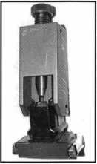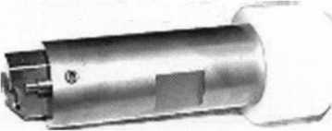

The G.M. Trunk & Door Persuader

The unique tool will open virtually all GM trunks and doors through the current year when tool fits into the cylinder core cavity in less than 50 seconds. No drilling, pulling, picking, special tools or electricity needed. When customer’s key does not open trunk because: Problem 1: spring retainer popped up into outer shell; Problem 2: One side of side bar sprung off. Side bar does not retract; Problem 3: key or cylinder worn. Side bar does not retract; Problem 4: Key jammed in lock at ‘‘turned’’ position, etc. With The Persuader you will open these locks in less than 50 seconds with no damage to lock. Just repair and replace. There is nothing to wear out. Yes, if needed, it will open with no key. Note: Because of The Persuader’s capabilities, it will be sold to locksmith only. $45.00 + $6.00 S&H

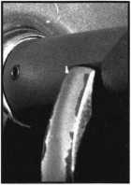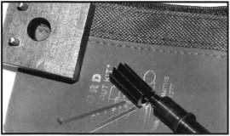

Ford “Disc-Out” Kit (patent 4682308)

This kit will remove those stubborn Ford pin ignitions from 1976 to present in less than 5 minutes. These locks incorpo­rate 2 locking devices and a hard steel disc across the shear line. They must be turned to “on” position to release both locking devices so as not to damage the housing. $60.00 + $6.00 S&H

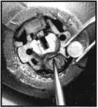

Frank Markisello guarantees all his products to do as stated.

[www.aablelocksmiths.com](http://www.aablelocksmiths.com) • 8619 97th Ave. • Ozone Park, NY 11416 • (718)848-8000

**Visit us at Booth #1321!**

**AUG I JULY JUNE**

**upcoming**

4 Ohio Valley Chapter of ALOA Membership Meeting 7pm Ryan's Steak House Mehdi Zahedi (937) 294-4241

7-8 Ozark Professional Locksmith 10 Association • Intermediate and Advance Master Keying Betty Gray 479-524-3660



2 Ohio Valley Chapter of ALOA Membership Meeting 7pm Middletown, OH Mehdi Zahedi (937) 294-4241

11-12 6th Annual American Lock

Collectors Association Lock Show

Cleveland, Ohio

Jon Kolozvary 440-243-2032



Fox Valley Chapter Membership Meeting 6:00pm Columbus Club • Appleton, Wl David Clark

[daveslocknkey@greenbaynet.com](mailto:daveslocknkey@greenbaynet.com)

24

6 Ohio Valley Chapter of ALOA Membership Meeting 7pm Middletown, OH Mehdi Zahedi (937) 294-4241

28-31 Second Annual IAIL Convention 10 Mt. Laurel, NJ Don Shiles 800-598-9491 [www.iail.org](http://www.iail.org).

Fox Valley Chapter Summer Picnic Road Outing America David Clark

[daveslocknkey@greenbaynet.com](mailto:daveslocknkey@greenbaynet.com)

San Diego Chapter of ALOA/CLA

Membership Meeting 6:30pm Linda Vista Village Clubhouse Mike Perry (858) 967-9761



UPCOMING PRP SITTINGS

6/1/2003

6/7/2003

6/8/2003

6/12/2003

6/22/2003

6/12/2003

6/22/2003

7/10/2003

7/19/2003

7/20/2003

8/7/2003

8/17/2003

8:30AM • Lewistown, MT Montana Chapter of ALOA Michael Alexander 406/549-5625 9:30 PM • Kalamazoo, Ml W. Ml Locksmith Assn.

Mark Blum, CML, CPS 517-482-5809

9AM • Fairborn, OH

Ohio Valley Chapter

William M. Lockwood, CRL

937/836-6127

8:00AM • Dallas, TX • ALOA

Janelle Ramirez 800/532-2562 X30

1 PM • Farmington, NM

New Mexico L.A.

Deborah Pipkin 505/327-7500 8:00AM • Dallas, TX • ALOA Janelle Ramirez 800/532-2562 X30 8:00AM • Reno, NV Clark Security Products Joan Emrick 619/718-7308 8:00AM • Dallas, TX • ALOA Janelle Ramirez 800/532-2562 X30 8:00AM • Las Vegas, NV • ALOA Janelle Ramirez 800/532-2562 X30 8:00AM • Las Vegas, NV • ALOA Janelle Ramirez 800/532-2562 X30 8:00AM • Dallas, TX • ALOA Janelle Ramirez 800/532-2562 X30 8AM • St. Pete, FL • SERLAC Ken Kupferman 800/845-5294

9/11/2003

9/21/2003

9/28/2003

10/9/2003

10/18/2003

10/25/2003

10/26/2003

11/13/2003

11/16/2003

12/11/2003

8:00AM • Dallas, TX • ALOA Janelle Ramirez 800/532-2562 X30 8:00AM • Anaheim, CA Clark Security Products Joan Emrick 619/718-7308 8AM • Kansas City, MO Missouri-Kansas Locksmith Assn.

Greg N. Brandt, CML816/444-3233 8:00AM • Dallas, TX • ALOA Janelle Ramirez 800/532-2562 X30 10:00AM • Chamblee, GA GA Chapter of ALOA John C. Elliott,Jr.,CML,CPS 770/314-7859 9:00 AM • Sturbridge, MA Yankee Security Convention Jack Hobin 800/209-8266 10AM • Mt. Laurel, NJ • G.P.L.A. Martin Arnold, CML 856/665-0464 8:00AM • Dallas, TX • ALOA Janelle Ramirez 800/532-2562 X30 TBD Montgomery, AL Alabama Locksmiths Assn.

Amanda Boyd 334/793-5060 8:00AM • Dallas, TX • ALOA Janelle Ramirez 800/532-2562 X30

UPCOMING ACE CLASSES

June 14

June 20-21

July 14-18

Sept. 13-14 Sept. 20-21

Sept. 26-27

November 15

Vancouver, BC (Canada)

BC Association Of Security Profsnls. Jerune Rodermond 604-607-6604 Farmington, NM • New Mexico Locksmiths Assn. Convention Deborah Pipkin 505-327-7500 Las Vegas, NV • ALOA David Lowell, CML, CMST 800/532-2562 xl8 (75 ALOA ACE Classes)

Gulf Shores, AL • AL Locksmiths Assn. Amanda Floyd 334-793-5060 Syracuse, NY • Central New York Locksmith Association Ron Smith 315-782-0912 Casper, Wyoming Wyoming Locksmiths Assn Gene Ficek, CPL 605-6424542 Montgomery, AL • AL Locksmiths Assn. Amanda Floyd 334-793-5060

**events**

25 Pacific Locksmith Association Membership Meeting 6:30pm Denny's Restaurant Tualatin, OR Dan Cunningham 360-835-1191 [www.pla-pro.org](http://www.pla-pro.org)

29 The North Jersey Master Lock­smiths Association 9th Annual Flea Market • Lyndhurst NJ Jeff Sitan at 973-777-0620 or Mr. Lascar/Hart 201-944-7547



**SAFE CORPORATION**

MANUFACTURES OF QUALITY DEPOSITORY SAFES AND CHESTS

DISTRIBUTING FROM WAREHOUSES IN

•LOS ANGLES, CA

* CHICAGO**;** IL
* GLASSBORO, NJ

A & B is now a stocking distributor

for Mutual Safes

featuring

**uiui** my

ll

ttl

AB-4-30-3S AB-9-2 WS 10-2

Chose from over 75 models in stock

We ship your order within

24 hours

See us

*of [www.a-bsafecorp.com](http://www.a-bsafecorp.com)*800-253-1267  
Fox 856-863-1208

CALL FOR YOUR  
CATALOG TODAY

**core**

VEGAS 2003: VAN AUCTION

The ALOA Scholarship Foundation, Inc., will once again auction a van package at the 2003 ALOA Kickoff Party in Las Vegas. The package includes:

* A 2004 Ford E-150 V-6 Automatic
* Adrian Steel Interiors Locksmith Package
* Kaba llco Rocky Mount 045 Key Machine
* llco Advantage CD
* Magnum Pick Set
* LSDA (assorted products)
* Southern Lock and Supply (Various tools)
* Tech-Train Productions TT2050/QEHC

ALOA Open 2003

The ever popular ALOA Open Golf Tournament will be held at The Legacy Golf Club in Henderson, NV, on Thurs., July 17, 2003. The registration fee is $150 (tax deductible), and includes transportation to and from the course, greens fees, golf cart, beverages throughout the course, lunch and guaranteed prizes for each and every player. The main sponsor for the tournament this year is, once again, Yale Security Group. Other sponsors include Lucky Line Products, Inc., Strattec Security, Inc., AMSEC and Assa High Security Locks. Thank you to our sponsors for your con­tinuing support, and we hope to see plenty of convention attendees show us how it's done out there at The Legacy in July.

ALOA Code of Ethics

All members of the ALOA by acceptance and continuance therein, shall be deemed to have subscribed to the following Code of Ethics:

That the dignity of our chosen profession may be perpetuated, it is the duty of all members of the ALOA.

* To practice their profession in the spirit of fairness to their clients, with fidelity to security in conformance with appropriateness, and with high ideals of personal honor;
* To properly and impartially analyze security problems, and to advance the best possible solution for the protection of their clients;
* To conduct themselves in a dignified manner;
* To abide by applicable licensing and business regulations;
* To abstain from using improper or questionable methods of soliciting patronage, and to decline to accept such incompatible patronage;
* To refrain from associating themselves with or allowing the use of their names by any enterprise of questionable character, or in any manner countenancing misrep­resentation;
* To cooperate in advancing the best interest of the locksmithing industry by inter­change of general information and experience with fellow locksmiths;
* To encourage and promote loyalty to the profession, always ready to apply their special knowledge, skill and training for the use and betterment of our industry.

Letters to the Editor

Jimmy,

All I can say is "well done" with the Keynotes magazine. It's been refreshing to see the development and improvement. You're doing a fine job. Thank you.

Sincerely,

Tom Lynch New York

Keynotes Editorial Guidelines

1. Articles should be of a technical nature, rather than promotional. Technical articles will be of more benefit to our readers, and they are more credible. Articles that are primarily promotional are not as likely to be read or believed - just as a 30- minute infomercial on television does not hold viewers' attention for very long. Furthermore, Keynotes neither accepts nor pays for previously published material as if it were an original manuscript.
2. Articles should be of sufficient length to cover the topic adequately. Generally, this ranges from 1,000 to 1,500 word, but this can vary to individual authors' needs.
3. Copy should be typed (double space) with standard margins. Articles will be type­set to fit the Keynotes format and style. This gives the publication a consistent and professional appearance. Authors should submit copy via e-mail, or on computer disk as a Word or Text file, if possible. If not, the author should mail a clean, clear copy. FAX copies may be accepted under certain conditions.
4. Photographs should be in color, 4X6", with the captions attached to the print.

High Resolution digital photograph files are acceptable in the JPEG format, and can be submitted via computer disk or e-mail. (E-mail files are not to exceed 3 megabytes.) Amateur photographers may find it helpful to take their photographs outside - in early morning or on a cloudy day - using 100 to 200 ASA film.

1. Illustrations (graphics or drawings) can be included with your article. We prefer original art or drawings. No photocopies, sketches or "homemade" material will be used as original material. Material should be clear enough so that we can scan it into the computer. Camera-ready illustrations are greatly appreciated. Any mate­rial submitted that has been produced by another person or company must include the name of the original company with a copyright date.
2. Please submit a photograph of yourself, along with a short business biography (e.g., "Joe Q. Locksmith is the owner of Joe's Lock and Key in Upper Sandusky. He has been a professional locksmith for 15 years, and an ALOA member for 1 2 years. He teaches lockpicking and has obtained his CML designation.")
3. Solicited/pre-approved articles are due in the ALOA office by the 15th of the month, two months prior to the month of publication. For example, a solicited arti­cle for the December issue would be due no later than Oct. 15. Unsolicited arti­cles must be processed by the Publications Manager, and are scheduled upon approval, in accordance with the existing article menu. Average time to publica­tion for an unsolicited article is six months. Please indicate whether your article is time-sensitive.
4. The Associated Locksmiths of America, Inc. (ALOA) reserves the right to refuse any article for any reason. Additionally, ALOA reserves the right to edit an article for clarity, grammatical correctness and technical accuracy. Efforts will be made to notify the author of the changes, so that the author has a chance to approve the changes.

New Certifications

New CRLs

MIDDICK, MIKE C. • CANON CITY, CO ORDWAY, PETER • COLORADO SPRINGS, CO PRICE, CARL E • COLORADO SPRINGS, CO LOVEALL, CHRIS • AURORA, CO WALTER, BRAD W • LITTLETON, CO HUMES, EDWARD E • EDMOND, OK New CMLs

SMITH, KENT A. • LITTLETON, CO

Keynotes • June 2003

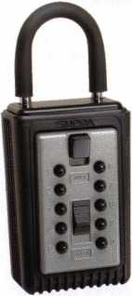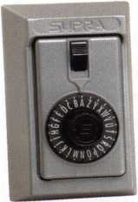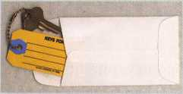

**\*$7.00 SHIPPING CHARGE ADDED PER ORDER** NY RESIDENTS ADD APPLICABLE SALES TAX

**SANZO SPECIALTIES, INC. BOX 68 ENDICOTT, NY 13760 TOLL FREE: 1-800-222-4041 FAX: 607-748-0507**

©SUPRA

**ALL METAL**

**PROFESSIONAL**

**AD / ID KEY TAGS**

Specifically designed to identify the product you work with daily and promote your business with your custom Ad copy.

**PUSHBUTTON**

1-4 37.95 EA. / 5-9 34.95 EA.  
10 or MORE 31.95 EA.

No Home Should Be Without One  
The Surface-Mount S-5 Supra  
Lockbox is a product you can provide to  
any homeowner, easily priced to your  
customer in the $50.00 range installed  
(simple 4 screw installation). Carry one

Stock # S5-DIAL with you at all times to demonstrate - stock # S5-PUSHBUTT0N

Surface Mount Unit once shown it sells itself!! Surface Mount Unit

**Clear Plastic Protective Sleeves** Stock # PPS10

Protect your key tags with * 100 200 500 1000

durable plastic sleeves 11.50 19.95 42.00 68.50

**COMBINATION KEY BOXES**

®

Key Storage Lock Box

✓ALL METAL Construction

* Great Economical Pricing
* Simple to set/ Simple to open
* 5 Year Warranty

**SERIES LOCK BOXES**

Both models now have weather resistant  
ALL TITANIUM METAL CONSTRUCTION  
with metal back and buttons. Both models  
are also available with PUSH BUTTON  
COMBINA TION LOCKS that are easy to  
set & reset.

**DIAL**

1-4 36.95 EA. / 5-9 33.95 10 or MORE 30.95 EA.

Stock # C3-PUSHBUTT0N Removable KeyBox, DoorGuar rubber bumper protects surfaces

Stock #C3-DIAL  
Removable KeyBox  
DoorGuard rubber bumper protects surfaces

**Key Tag Envelopes**

Stock # KTE3 Actual Size: 2V x 4V Added security and finishing touch when presenting keys to your customers

* 100 200 500 1000

10.50 17.00 37.50 65.00

ShurLok has designed an all-metal key storage box that is the safest, most secure lock box on the market. Separate easy to set combinations open the shackle and key compartment — and the combinations can be changed in seconds. The ShurLok is so simple to use a child can open it, yet so versatile it will satisfy the Real Estate professional or anyone requiring key access in a lock box. Unique double combination allows all users access to key(s) while allowing only authorized users access to the shackle and will prevent lock box removal or theft.

TO ORDER: Choose QTY., Key Tags with Chains or Rings, TAG COLOR and Provide Imprint Copy (printed black only).

**1 to 9 $19.95 ea.**

**10 or more $17.95 ea.**

*if color is not specified we ship blue*

Stock #SLK100R

Brick Red

Stock #SLK100  
Blue

ANDOVER LOCK & KEY SERVICE

3221 LAKESIDE HWV.  
ANDOVER MA 05242  
(508) 626-1111

LAKE VIEW  
LOCKSMITH

24 Hour Service (845) 556-LOCK

**y y**

^

Choose from Brass Plated Bead Chains or Chrome Plated Wire Rings

|  |  |
| --- | --- |
| back side of tag with 4 lines for key identificatior  Jk KEYS FOR | 1 |
| r i |
| K| |
| SANZO- ENWCOTT, NY 13760 |
|  |  |

QUANTITIES100 200 500 1000 2000 3000 5000

it KEY TAGS with CHAINS or RINGS 32.00 42.95 83.95 115.00 195.00 269.00 395.00

YOUR CHOICE OF CHAINS OR RINGS - IF NOT SPECIFIED WE SHIP CHAINS

**Key Tags Only** (no chains or rings) - Deduct 10% from above prices National Logos - No Charge / Custom Logos - Add $25.00 and supply clean B & W artwork

**Set your own combination**

The combination can be changed in seconds —  
without special tools or disassembly. Changing  
the shackle combination also automatically changes  
the combination for the sliding key storage door.

change 1®.’000I f \ \ button Combinations

^ **Possible!**

IdD

Changing the combination

for the shackle  
only takes a few seconds  
with a simple turn  
of the change button.

**Products LOCKSMITH Professionals**

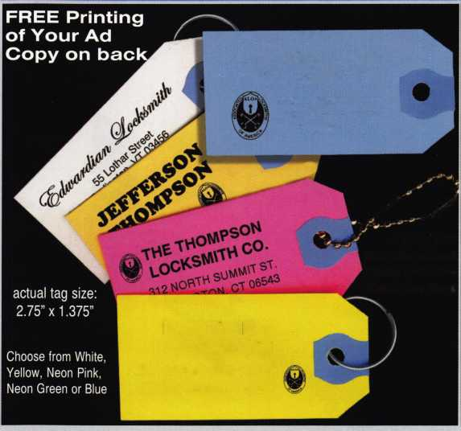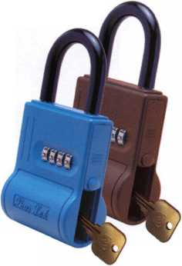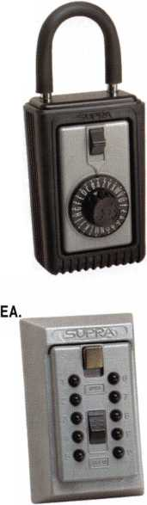

Medecc>3

By Greg Perry, CML, CPS

Photo 1 shows the difference between Medeco3  
(top) and standard Biaxial( (bottom). The slider  
can be seen just above the bottom of the key  
through the cutaway cylinder.

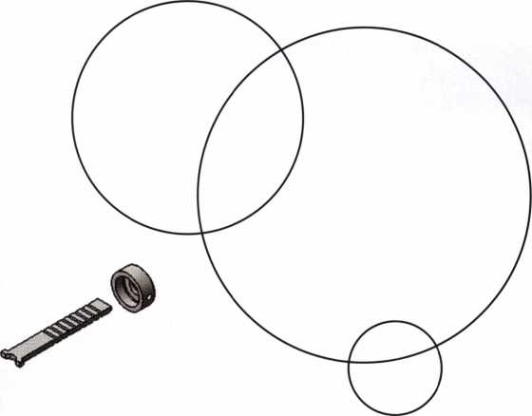

Medeco3 is here and no new pin kits or key  
machines are needed. (Thank you, Medeco!).  
Medeco has developed a new product to  
address the impending patent expiration of  
Bixial( in July, 2005. Since its founding,  
Medeco has been at the forefront of patented  
key and cylinder control. Medeco was the  
first to “mass-produce” a high security  
cylinder with their original product line,  
incorporating a rotating pin and a sidebar.  
Medeco originally started as a machine shop.  
Their name comes from the first two letters  
of word of their original name, Mechanical  
Development Company. The story I’ve heard  
is Yale Lock asked them to develop a high  
security cylinder design. Once developed,

Yale felt the product would be too difficult  
to mass-produce and too costly. After already  
investing a large amount of time and money,  
Medeco in 1968 decided to market the prod-  
uct themselves. During the mid 1980s,  
Medeco needed to update or redesign the  
product to maintain a market position with  
a patented product. The product was named  
Biaxial; not only did the pins rotate, but they  
added a fore and aft cut position. As the  
Biaxial patent nears the end of its life,

**12**

Keynotes • June 2003

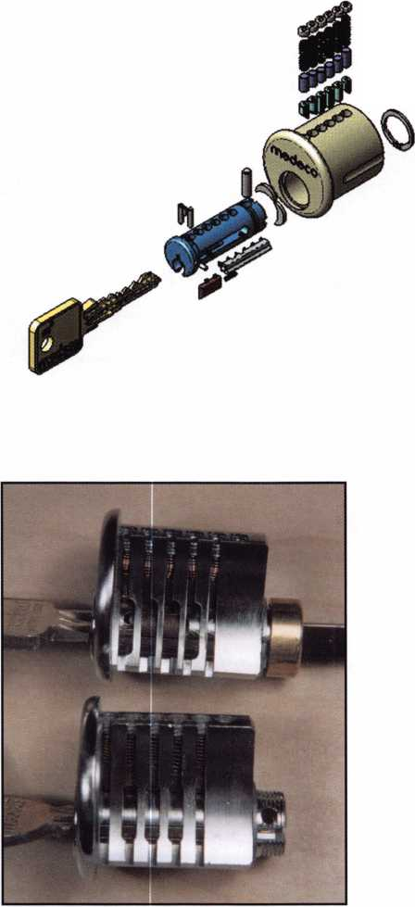

Medeco feels the need to release a new prod-  
uct to maintain their market position with a  
patent-controlled system. Medeco3 is that  
product. The addition of a slider mechanism  
and side milling or bitting on the key is the  
difference. The utility patent was filed on  
Feb 6, 2001, and is good until to Feb 6, 2021  
(20 years). My guess is about 2019, we’ll see  
another new product; perhaps it will be  
called Medecozj.. A few years ago, Medeco  
joined the Assa Abloy Group.

Medeco3 can be purchased for use with  
either the original pins or Biaxial pins.

This means that if you’re more comfortable  
with the original pin style (or Biaxial), you  
can service the newest generation of patent-  
controlled product, Medeco3 with a minimal  
investment. Obviously, new inventory will  
be required in the form of new key blanks  
and cylinders. In addition, new jaws are  
required for your existing key machine.

Add a little inventory in the slider parts  
and you are ready to provide your customers  
with Medeco3.

Medeco3 starts with a basic pin tumbler  
design with six depths and typically six pin  
chambers. The original Medeco style pins  
rotate right 20 degrees, center or left 20  
degrees, meaning there are three different  
pins associated with each depth. The rota-  
tion of the pin is accomplished by a chisel  
tooth design that matches the cut profile on  
the key. Each pin has a slot milled into the  
side. This slot, when rotated correctly, will  
allow the sidebar to enter the side of the pin.  
If all the pins are aligned at the sheer line and  
each pin is rotated correctly, the sidebar will  
enter the pins as the plug is rotated. If any  
pin is not at the sheer line, or if any pin is  
not rotated correctly, the plug will not turn.  
Biaxial uses a very similar concept with the  
addition of a fore or aft cut to the chisel  
tooth on the pin. Biaxial pins and cuts are

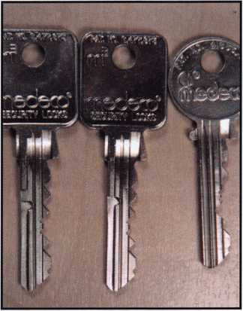

Photo 2 takes a look at three keys,  
on the top is a standard Biaxial.  
The middle key is a Medeco3 with  
master mill, and the bottom key is with  
the change mill.

Photo 3 shows two of the three different sliders and  
side bars. The top is the master only slide and the bottom  
is the combination slide.

Photo 4 gives us an idea of how the slider will block the side bar. The slider must move towards the back of the plug to allow the side bar to enter the pins.

Keynotes • June 2003

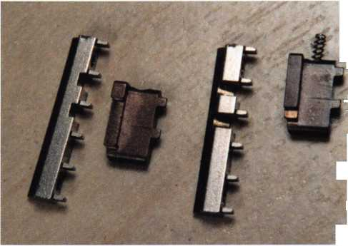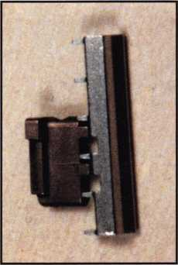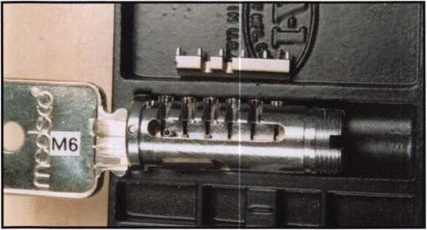

Photo 5 shows the key partially inserted, in this the position the  
slider is in the blocking position.

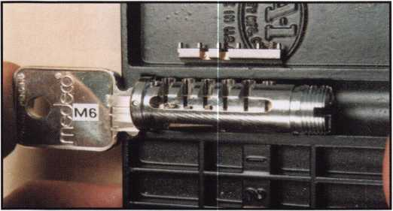

Photo 6 is with the key inserted all the way pushing the slider out of  
the way.

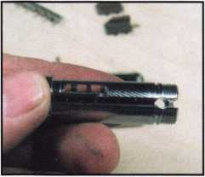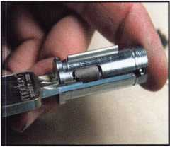

Photo 7 is of the cavity where Photo 9 the plug now has the

the slider goes. change milled key inserted,

it is pushing against a differ-  
ent step on the slider.

labeled K, B, Q, M, D and S. K, B and Q are  
fore cuts left center and right. M, D and S  
are the aft cuts, again left, center and right;  
a total of six different pins for each depth.  
The offset from center is .031; this also  
allows for a double cut in each space of the  
same depth. The double cut can be used to  
increase change keys under a given master  
key. Medeco3 adds a third level of locking  
to the plug. Medeco has added a slider and  
spring to block the sidebar from entering  
the plug if the correct key is not used.

The sidebar legs are modified for use with  
the slider. They are narrower, and the sidebar  
itself has two gates cut into it for the block-  
ing tabs of the slider to enter. The keys are  
available in two versions, a master side bit-  
ting and change side bitting. The reason for  
this is to limit a change side bitting key from  
operating a master-only cylinder, or limit a  
master key from operating a cylinder in  
which only a change key should operate.

This operation is achieved with three  
different sliders. The first is a combination  
change/master slider. Either type of key will  
push in the slider, allowing the sidebar to  
enter the plug as it is rotated. The second is  
a master-only slider; this slider will allow  
the change key to enter, but the slider is not  
being pushed by the key. The slider will then

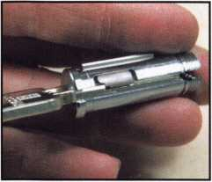

Photo 8 shows the bottom  
view with the master milled  
key inserted. In this picture  
you can see how the master  
key is pushing against  
the slider.

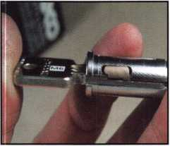

Photo 10 has the master only  
slider installed, the master  
milled key is pushing  
against it.

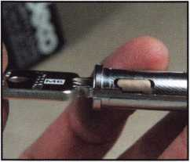

Photo 11 is the same  
master only slider with  
the change milled key  
inserted notice it doesn’t  
push the slider forward.

Keynotes • June 2003

block entry of the sidebar. The third is a change-only slider. I have not received a change-only slider, but I believe it operates by blocking or restricting the full entry of the master key into the cylinder.

Medeco3 has been Beta tested at several locations, including the factory. A Medeco3 cylinder is being tested at the factory and has surpassed 600,000 cycles without failure. I’m certain Medeco3 will be well received by the industry Being able to use your

existing pin kits and only needing to upgrade the jaw for your key machine is a plus towards changing over to Medeco3. My thanks again to Medeco for creating a locksmith-friendly product. I would also like to thank Gordon Malzcewski and Clyde Roberson of Medeco. They provided the pre-launch product sam­ples at the last minute for this article. Be sure and visit the Medeco booth at the ALOA show in Las Vegas to see the product.

**Buying From Nebs**

Savings

Put a

call, **order**

Professional Business Products, your  
Associate ALOA Member, offers you  
lower prices, two color ALOA logo  
on standard forms and rebates to ALOA!

**For more information, visit us online:  
[www.professionalbusinessproducts.com](http://www.professionalbusinessproducts.com)  
or call 1-800-355-6322 for our catalog.**

*Professional*

*Business*

*Products*

**15**

Keynotes • June 2003

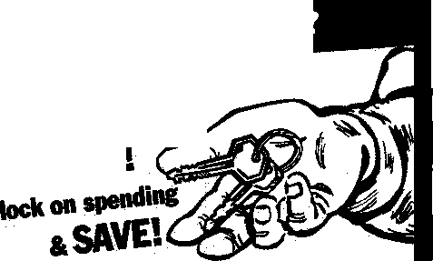

The Ultimate Weapon in Locksmithing -

A Killer Service Truck by Ed Wood, CRL, CPS

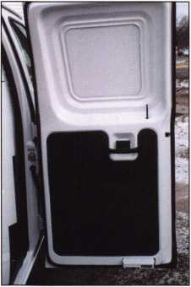

Photo 1

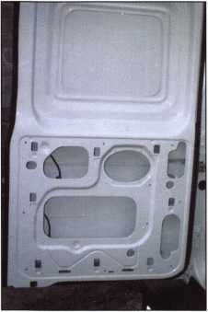

Photo 2

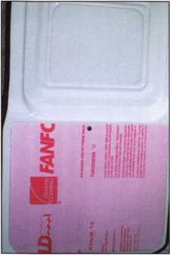

Photo 3

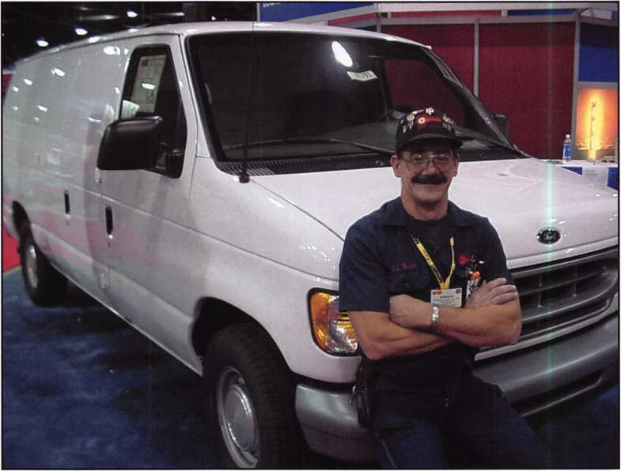

First things first: Let’s thank ALOA and the ALOA Scholarship Foundation for the great door prize at the 2002 convention. Yeah, this is the van they GAVE away last year as a door prize. Also, let me thank KNAACK-WEATHERGAURD for the donation of the interior and cabi­nets. Don Rule, CML, from ALOA and Jack Daniels from KNAACK both worked with me to transform the van and interior into a killer service truck. First, we bumped the E-150 up

to and E-350 Super Cargo van. Next, we added power windows, locks, remotes keyless entry, tilt wheel, a rear heat/air conditioner, and last but not least, a 7.3 power stroke, turbo-charged diesel under the hood. Living in Northwest Indiana, we get a full four seasons ranging from 10 degrees below zero in winter to 100 degrees in the summer sun; that’s the reason for the twin front and rear heat/air condition­er units.

**6**

Keynotes • June 2003

The first thing was to insulate the van for lasting temperature control. Photo i shows the door the way it arrived from the factory Photo 2 shows the plastic lower panel removed showing no insulation. Photo 3 shows polystyrene insulation I used on flat areas. Photo 4 is the aluminum foil covered bubble wrap insulation I used in more contoured areas — also the Polyurethane adhesive I used to glue pegboard to doors, as well as screws. On the lower portions of the doors,

I shimmed the pegboard out using a one-inch strip of pegboard to facilitate the clearance for the hooks as seen in Photo 5. Photos 6 and 7 are the before and after shots of the driver’s side inner wall. After insulation, it was time to install the cabinetry KNAACK has a dimensional layout of all the common cargo vans in their catalogue to help us figure out how to use your space. I didn’t use a standard package of cabinets, but chose to make up a customer package.

First up was the bulkhead behind the driver’s compartment; it’s the new sliding door style, so the door never blocks other cabinets. It also keeps the rear equipment back there if you make a panic stop , where they can’t slam you in the back of the head. All the cabinets have a secure locking sys­tem to keep the doors and drawers shut while traveling down the road. The main work bench was placed right behind the driver’s seat for the easiest access. A major consideration in laying out your cabinets is weight placement.

You need to try to balance the weight from side to side as much as possible. Another thing to consider is, if you’re using an extended van like I am, not to put the heavy things behind the rear axle. Placing the heavier items behind the rear axle causes the vehicle to be less stable than when you balance it between the axles, eliminating the teeter-totter effect. When installing the cabinets, use caution in drilling holes in the floor, especially as not to drill into fuel tank, wiring, cooling lines, and anything else running under the floor, or in the walls. As I installed each cabinet, besides the bolts and locknuts supplied, I applied some polyurethane adhesive between sur­faces to stop the squeaks down the road (Photo 8 and 8a). This is a trick I learned many years ago while work­ing for an outfitter of service vehicles. A little extra effort now will save a lot of headaches down the road. The work bench is configured in such a way that, from my seat, I can easily reach the most common key blanks, pin kits, code machine, duplicator, fol­lowers, and the most commonly used hand tools. My local fab shop made up the inclined mounts for the key machines, making them easier to access from a seated position. (Photos 9, 10 and 11). Over the work bench is a four-foot florescent light, which had the ballast removed and replaced with a “o” degree start. Most shop lights come with a “50” degree ballast, and that’s why they flicker when you turn them on when it’s colder than that.

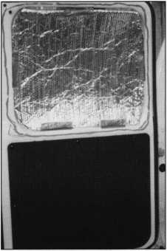

Photo 4

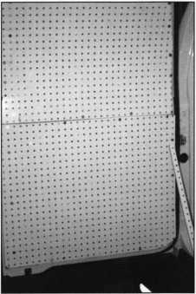

Photo 5

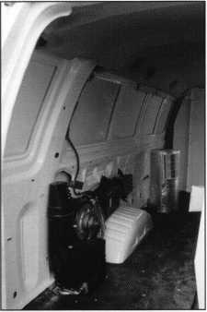

Photo 6

Keynotes • June 2003

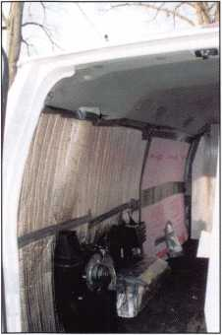

Photo 7

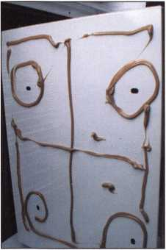

Photo 8

The other modifications to the shop  
light were “TRU-DAYLIGHT” bulbs  
and tube locks to keep them in place  
while bouncing down the Northwest  
Indiana roads; both can be purchased  
at any good electrical supply house  
(Photo 12). Powering the light is a  
TRIPP-LITE 1800-watt inverter. It  
easily runs the light and key machines  
as well as my planer, die grinder, or cir-  
cular saw After much shopping

around, the place  
to get your con-  
verter is a major  
made truck stop  
like the Flying  
“J.” They had the  
best selection  
and the best  
price I could  
find. Ford motor  
company made  
installing an  
inverter a snap.  
Back in 1998,

when I bought my current van, I

ordered an electrical wiring manual,

which showed a circuit already

installed to charge an auxiliary batter

in a camper. This meant no need for a

splitter to isolate the inverter battery

from the truck starting batter. This  
Photo 9 &

truck has the exact same wiring, so

the hook-up was a breeze. The invert-  
er battery is installed in a marine bat-  
tery box for safety, just behind the dri-  
ver’s seat. On the bulkhead, I mount-  
ed the inverter with room enough so I  
could still slide my seat all the way  
back (Photo 13). The manufacturer  
recommended #2 gauge wire from the  
battery to the inverter, which is a  
heavy gauge of batter cable that was  
purchased at an auto parts store. The  
next safety precaution was to run the  
power from the inverter straight to a

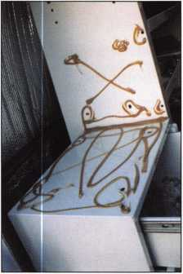

Photo 8a

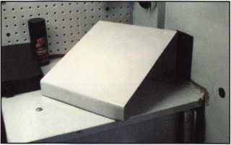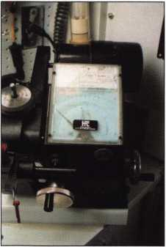

Photo 10

20-amp GFI. The GFI (Ground Fault Interrupter) will trip if a short arises, keeping you from getting an electrical shock.

All the wiring was run inside a non- metallic conduit to prevent chafing or pinching of wires. Aside from the out­lets for the machines at the work­bench, an additional outlet was run to the rear of the van and a 30-foot reel retractor cord was installed with a drop light (Photo 14). In addition to the no-volt AC outlets, two 12-volt DC outlets were installed off of the auxiliary battery. The battery and inverter were mounted on the bulk­head right behind the driver’s seat making the on-off switch easily acces­sible and keeping them out of harm’s way All the KNAACK cabinets have a gloss white finish, which helps with the light reflection, making the one florescent ample light for this van.

All the cabinets came with more than ample fasteners, but I substituted 5/16 tinnerman clips for the top anchor points near the roof. The sheet metal self tapers and nut-serts work loose after a year or two, but the tinnerman style nut with a drop of thread lock will be there five or six years down the road. All that’s needed to install these type of fasteners is to drill a 7/8-inch hole just over from your 5/15-inch anchor point to insert the nut portion in back to squeeze the sheet metal tight (Photos 15 and 16). These are automotive style fasteners, and are used to hold fenders on many vehicles. Raise the hood of most any car and you will find these style fasteners where the stainless steel bolt, fender washers, and locknuts for fastening through the floor of the van.

**18**

Keynotes • June 2003



The cabinet on the driver’s side over the rear wheel well took extensive cutting and shaping to accommodate the rear heat/air unit (Photo 17).

After laying it out, you also need to carefully plan the use of the space on the middle shelf, so as not to block off the supply of hot or cold air coming from the two vents (Photos 18 and 18a). The American key boxes each hold 500 different keys with 10 to 14 keys per hook. One was set up for automotive, motor­cycle, club and heavy equipment keys. The second was filled with house, padlock and other cylinder keys (Photo 19). Different locksmiths need different blanks depending on your geographical area and your type of work. My old buddy Gary Perry and I were discussing truck inventory one day, and our inventory isn’t even close to being the same.

A bulk of his work is safe deposit work, with very little automotive — just the opposite of mine. Don’t get me wrong: We both have some things that we both stock in our truck, but it would be unrealistic for me to make up a list of stock, keys, or even tools you all should have in your truck. So, as I list some of these things, you need to realize that this is a key board that uses the H. E. Mitchell mobile key hooks for the most popular house and automotive keys that can be reached from the seat at the work bench (Photo 20). Another thing noticeable about the interior is the use of the tool holders from Snap-On YA 3123A and YA3182A (Photo 21). The mag­nets used to hold tools, small parts, and even notes are attached in some cases using polyurethane caulking adhesive. On 40 per­cent of the 40-60 side doors was great space to store “my favorite” car opening tools, wedges, and lights (Photo 22). The bulkhead

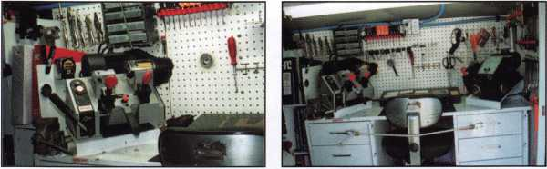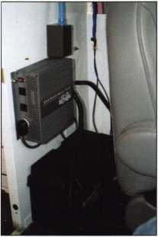

Photo 12

Photo 11

Photo 13

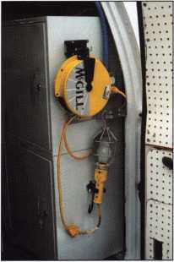

Photo 14

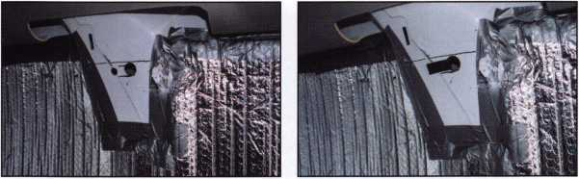

Photo 15

Photo 16

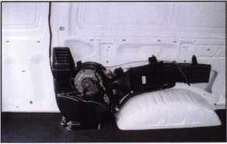

Photo 17

Photo 18

Photo 18a



Keynotes • June 2003

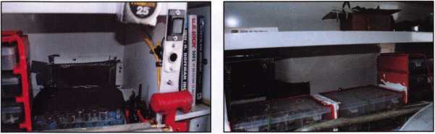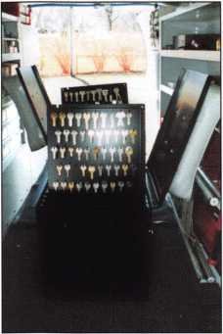

Photo 19

Photo 20

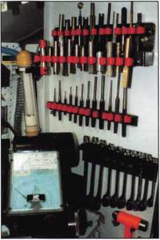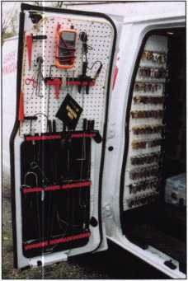

Photo 21

Photo 22

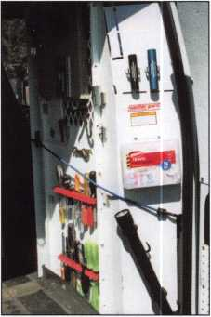

Photo 23

also makes a good place to hang flashlights, tools, first aid kits, and most anything else you use regularly (Photo 23).

The cabinets all the way to the rear were meant to be used for cable TV converter boxes, but they make a perfect spot for all the face cap and automotive pin kits on my truck. I do a considerable amount of auto work, so there are both domestic and foreign kits that need to be protected from spillage, due to the major investment. The saying around here is, “He who spills the pink kit sorts it alone!” These kits are bulky in plastic boxes but don’t weigh all that much, so behind the axle they went. Padlocks, rim, mortise and knob cylinders were moved to more forward positions, as they are heavier items. A non-skid drawer liner was also rolled out on the shelves to quiet the noise and keep the plastic containers from sliding around. In Photo 24, the key board on the left is stocked with the most commonly used keys fro my truck, including house, padlock, and automotive. On the floor is a Jensen tool case, which I use to carry my tools for servic­ing steering columns and ignition locks. It looks impressive when you open up the truck for tools. It also gives a more professional look when you sit it on the passenger seat rather than a tool box (Photo 25).

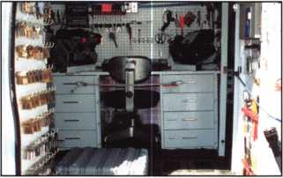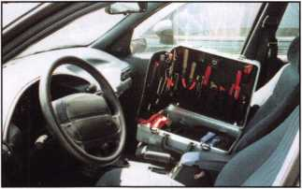

Photo 24

Photo 25

Keynotes • June 2003

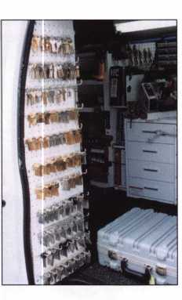

One of the final touches was for Sign Oddesy to install my vinyl graphics on the exterior of the van. We use the red key with KEYED RITE INC. over it on our business cards, let­ter heads, phone books ads, vans and even the clock on the wall in the shop. Take a look at my new license plate (from Found a Home) wrapped around the new vanity plate; I know it’s the wrong word — it’s a play on words to make them think. Another detail is I use the ALOA and SAVTA logos on it, just as I have on my previous vans. Once again — THANK YOU ALOA Scholarship Foundation and KNAACK-WEATHERGUARD for the great prize, as this article wouldn’t be possible without them. Congratulations to the future ALOA van winners — I hope you enjoy yours as much as I’m enjoying mine. (Photos 26-32.)

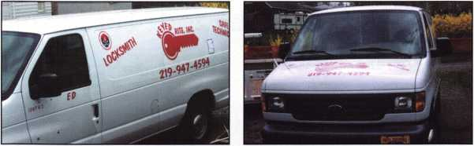

Photo 26

Photo 27

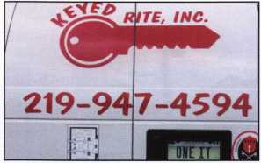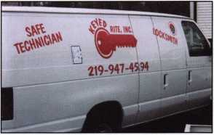

Photo 28

Photo 29

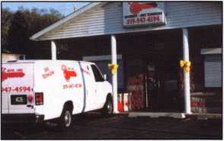

Photo 30

turpi 10

WHOLESALE SERVICE

In-Stock... **SAFES** FREE Freight Program Fax: 800-391-4553

800**-**848-9790

AMSBC FireKing GatiaH HAYMAN MEIUNK ^CTOft

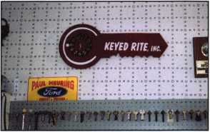

Photo 31

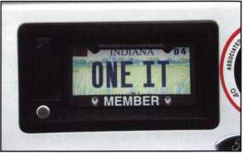

Photo 32

Keynotes • June 2003

Tryout Keys and the 2002 Ford Explorer

By Red Howell, CRL

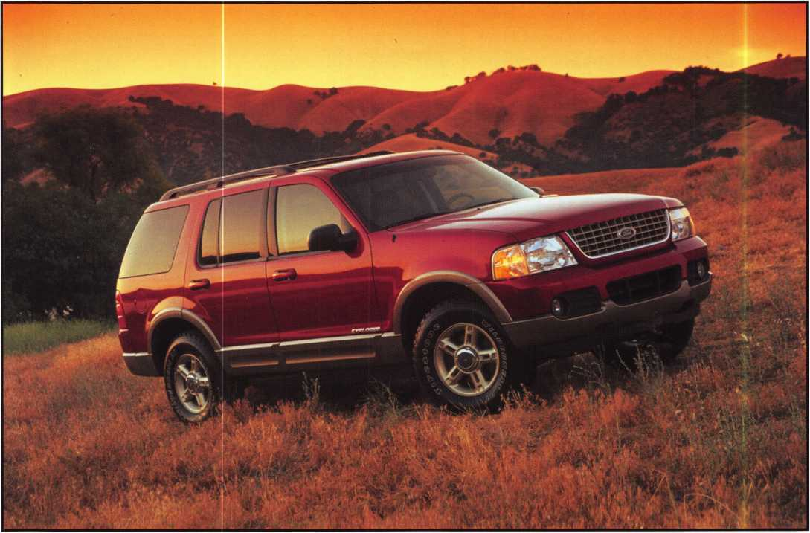

There are several different approaches or options for making a key for this vehicle. The following lists a couple of options when making a key: impressioning, disassembly or using tryout keys. From my 30-plus years of experience in the automotive industry I have found using tryout keys is often the best solution. Impressioning causes stress on the lock and disassembly is time consuming and increases the risk of damage. Several manufacturers make tryout keys, yet I have found tryout keys made by Baxter Systems to be the most accurate and the easiest to use.

During a recent California Locksmiths Association (CLA) meeting in San Diego, I was talking with Terry Morse of SOS Lock and Key about tryout keys for automotive locks. He mentioned he was having a dif­ficult time making keys for cars and wanted to know the best tryout keys to use. I mentioned Baxter Systems for tryout keys and suggested he try them.

I talked to Dennis Baxter of Baxter Systems about the two of us going to a local car dealer to use one of his sets. He said, “How about our new Set 99 on a 2002 Ford Explorer?” Dennis told Terry what were going to



Keynotes • June 2003

do, and he asked if he could come also. Dennis called me to see if I would mind, and I told him it was fine with me. Dennis and I both enjoy teaching, and since Terry had little experience with tryout keys, we knew it would benefit him also.

We all met at the Ford dealership at about 5 p.m., and were given permission to use the new 2002 Ford Explorer behind the showroom building. It is so nice to find cooperative car dealers like Drew Ford of La Mesa, CA.

The 2002-2003 Ford Explorer is on the Ford 8-cut system. It differs from most other 8-cut Fords in hav­ing door tumblers in positions 2 through 7, instead of the more common positions, 1 through 6. This door tumbler arrangement is shared with the 2002-2003 Mercury Mountaineer, and all years of the Lincoln LS.

We handed the Set 99 to Terry and said, “Go for it!” First, he determined that the bottom side of the lock had the first tumbler, using the “notch tip” key fur­nished in the set. Then he started trying them in the driver’s door lock (the only door lock on the vehicle). He used the keys, according to the instructions, which state to start with the first key in group 1, and try both sides of each key. When side 50 (of 202) was on the bottom, the key turned. This happens to be the side at which 50 percent of the possible combina­tions have been covered.

This step is to make a key to use to finish the door key by impressioning. To do this, determine the start­ing cuts, from the cutting chart, for the side that operated the lock. For side 50, they called for the fac­tor depth cuts 244212 to be made on an H60 or equiv­alent blank. Of course, this Explorer has a transpon­der key, but here, we are only concerned with using Set 99 to determine the correct cuts. These could then be transferred to the correct transponder key and programmed as a functional key.

Using the code machine in his mobile unit, Terry made the cuts 244212 on both sides of an H60 blank. He then tried to impression it t in the door lock to determine the correct depths in each position. He was not getting any marks, so Dennis demonstrated

the correct way to do this step. The key is turned to the right and rocked up and down twice, then turned to the left and rock up and down twice. This is repeated several more times in each direction, until fairly clear impression marks are visible. We only rock the key up and down twice because the tumblers are pushed away from the key by that time and further rocking at that point is useless.

When this had been done, the key was removed and good marks were seen in positions 2 and 5 (the first and fourth cuts on our key). At this point, I decided to show Terry the proper use of the Pippin file to fin­ish the key. I dropped down to one knee, and holding the key on my other knee, I deepened the positions with marks. All it takes is a few firm strokes in each position for the cuts to be deepened by the file. Once this has been done on both sides of the key, was inserted into the door lock. This time, it started to turn, as I was resuming impressioning. When the key was removed, there was a very obvious mark in posi­tion 7.1 again deepened this position on both sides, and now, the key operated the door lock smoothly.

My key was cut 344313 in positions 2 through 7.

The ignition lock has tumblers in positions 2 through 8, as do all 8-cut Fords. This means that once you have the correct combination for the door lock, you only need to progress position 8 to finish your key for the whole vehicle. I handed the key to Terry and said to try it in the ignition lock. This was because we wanted to see if the eighth cut was a #1 depth, and it was, since the key also operated the ignition smoothly.

In his tryout set instructions, Dennis says to use a code machine, guide keys or a clipper to make the cuts on your key blank after the operating key has been found. Those of us out in the field actually doing the work don’t always have the luxury of having these tools readily at hand as we impression, so Dennis agreed that being skilled with the Pippin file is also a very valuable skill. A round file can also be used, but the Pippin works better because of the smoother transitions from cut to cut.

Until next time, keep on cutting!

**23**

Keynotes • June 2003

Diebold’s Fearsome Maximus

By Greg Perry, CML, CPS

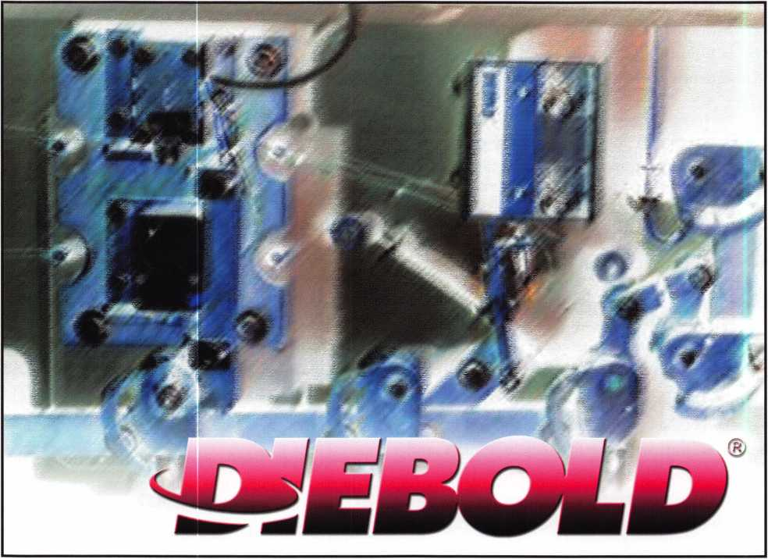

It’s a name that strikes fear into many safecrackers’ heart. I spoke with a Diebold technician from central California who said he only knew of one man in the whole country who could open a Maximus, SAVTA president Skip Eckert, CML. I can think of many others, but the Diebold technician gives you an idea of how difficult some feel this safe might be to open if something goes wrong. The Maximus carries an Underwriters Laboratories TRTL30X6 rating. This means the safe is torch (TR) and tool (TL) resistant for 30 minutes. The “x6” indicates six-sided protec­tion. Safes without the “x6” have only the door tested. I have not had the pleasure of opening a Maximus, but I have worked on several. If the call comes to open one, I’m about three-quarters ready More later about what I’m missing.

The Maximus is made in Israel by ISM. The construc­tion is similar to other ISM safes. Three-way bolt- work locks the top bottom and open edge. The hinge side is secured with fixed pins or bolts. The body is 4 1/8” thick comprised of steel, aluminum and concrete. The overall size of these units is 66” tall, 30 3/4” wide and 31 3/4” deep. The doors are 61” tall by 26” wide overall the doors are 7 7/8” thick with a distance of 3 3/4” to the lock bodies. The locks are mounted on a steel plate bridged over the top of a large tempered glass plate with two relock wires attached. Both ends of the wires are attached to the plates. They are attached to different pivot point cams within the safe from one safe to the next. The two safes I have pic­tured show the same location for the bottom relock, but the top relocks are located at different locations.



Keynotes • June 2003

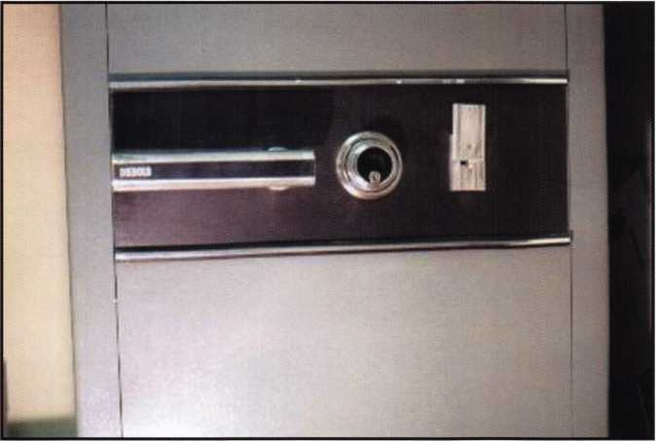

1. This is the outside view of the handle, dial and key lock area.

The operation of the relocks is an internal pin, ball bearing, and spring pushing against a relock pin that when fired prevents the cam from turning. The cable wraps around the base of the cam mounting plate to retain the pin. If you should ever need to overcome a relock, drill for the center of the cam and remove the spring. The relock pin then needs to be pulled out of the blocking position. Deciding which cam location is perhaps the most difficult decision. This is where good record keeping and documenting any safe you work on is important. Each of these safes is documented in my library should I ever need to open one because of a fired relock. It’s doubtful at this time that a relock will fire on these safes, anyone care to guess why? Look careful­ly at the photographs; I’ll answer in the closing paragraphs.

Diebold/ISM installs two locks on the Maximus; the combination lock is the Sargent & Greenleaf Group 8500 series lock. This is a three- wheel lock Group 1 manipulation-proof lock. The major difference from a 6700 series group 2 lock is the removal of the lever spring and the addition of an accelerator spring and a small “S” spring to keep the fence off the wheel pack if the combination is incorrect. Operation of the lock is to dial the combination 4.x left, 3X right, 2 left, and finally ix to “o” then push the dial in, release and continue to turn to the right, retracting the lock bolt. Pushing in on the dial releases the accelerator spring, causing the lever/fence assembly to jump toward the center of the wheel pack. If the gates are lined up, the lever drops and you can retract the bolt. If the wheel gates are not aligned, the small “S” spring will lift the fence off the wheel pack, effectively pre­venting manipulation.

The second lock is a key lock made by Mauer. Two different locks are used on the Maximus; the first is the 9 lever Praesident. The other

2. This gives an idea of how thick this door  
is; the bolts are 1 1/2” diameter.

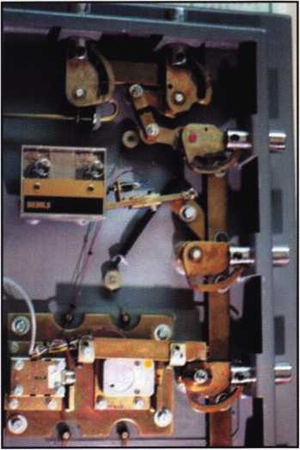

3. This is the top view of a safe number 1. It  
show the correct location of the time lock  
snubber bar and it has a switch on the top of  
the snubber bar that could be tied o an  
alarm panel to indicate that the boltwork is  
in the open position. It could be used for a  
door left open too long alarm.

Keynotes • June 2003

% /

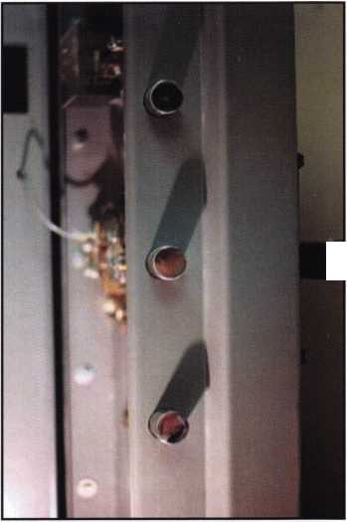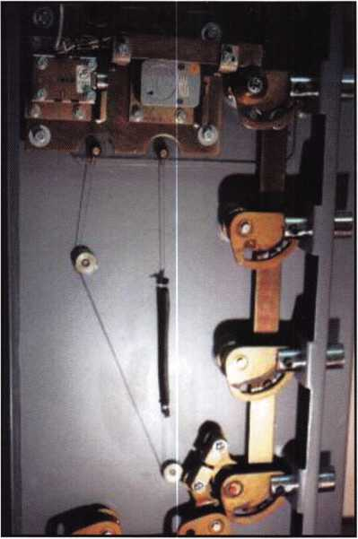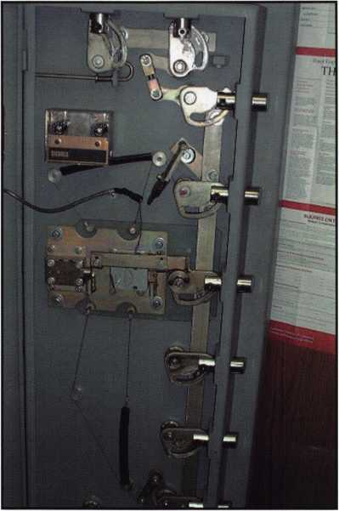

4. This shows the inside bottom view of safe  
number 1.

5. This is the inside of safe number 2, as you can  
see the time lock snubber bar has fallen out of the  
time lock.

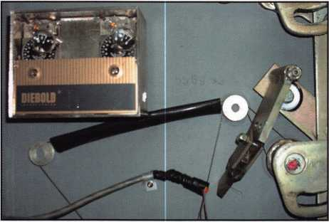

6. This is a close up of the time lock and upper relock area.  
Compare it to photos number 3 and 8 and you’ll see the  
different location of the relock wires.

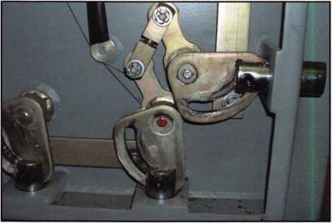

7. Here is a photo of the bottom relock area of  
safe number 2.

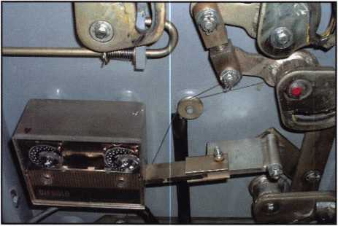

8. This is a good view of the time lock and relock area, on  
still a third Maximus. The top relock location is the same as  
safe number (Missing from this safe is the switch on the time  
lock snubber bar.)

**26**

Keynotes • June 2003

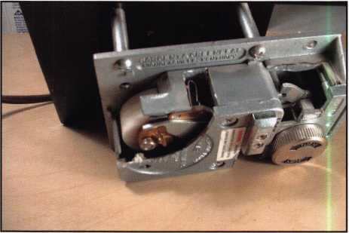

9. This is a view of an S&G 8560 cutaway lock showing both  
the accelerator spring and the “S” spring used to keep the  
fence off the wheel pack. The bearing on the drive cam is  
used to load the accelerator spring on to the ledge you can  
see just above the spring.

lock used is the 12 lever Rhenus. The reason I’m only three-quarters ready to open one of these units is because I’ve not been able to actually work on the key locks of these safes. My customer only has me change the combination of the 8500 series locks. I’ve offered a number of times to perform a complete service on the doors but they have a serv­ice contract with Diebold. Thus, I’m relegated to only working on the combination lock. I still take pictures and dimensions just in case of a lockout.

You’ll also notice the time lock snubber bar in safe number 2 has fallen out of the time lock case. This has been a chronic problem for this safe.

I found it like this the last time I changed the combo. I noted it on the invoice and informed the security officer. Again not my problem to repair, Diebold needed to come fix it again under their service agreement. Sometimes it gets frustrating to not be able to fix problems encountered when changing the combination but the customer is unwilling to pay me for a complete service or to fix problems like the snubber bar.

Anyone notice why the relocks will not be a prob­lem? The shipping bolts are still in place, this was pointed out to me several years ago on the SAVTA web site ([www.savta.org](http://www.savta.org)) when I first started chang­ing combinations and was concerned about the deteriorated rubber grommets. They are cracked and brittle, my concern was the possibility of the grommets allowing the wires to relax releasing the relocks. I posted pictures and asked about the pos­sibility of them firing. Instead Skip Eckert pointed out the red-headed shipping bolts. These bolts pre­vent the relocks from firing during shipping, should the glass break. They should be removed after the safes have been delivered. Again I’ve notified the security officer and noted it on the invoice as I’ve changed combos but my customer prefers to have Diebold perform any other service work on the safes. If the day ever comes that a relock fires or the combination lock fails, I’ll be ready. But if the key lock fails, I may just have to call Skip.

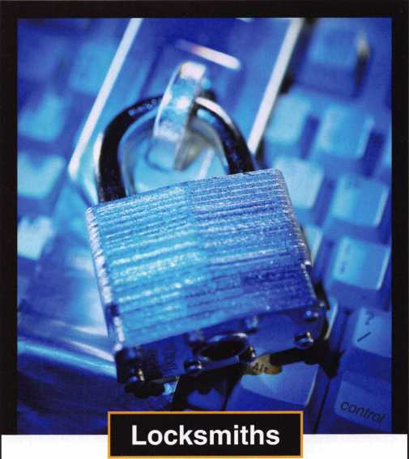

The Central Intelligence Agency is seeking Locksmiths to work with the best minds in the country while performing a mission critical to our nation.

To qualify for this position, candidates must have a bache­lor’s degree in a technical discipline and/or the equivalent of 3 to 5 years’ work as a locksmith and/or in the area of physical security. Knowledge of electronic and manual safe lock servicing, electricity, and alarms is ideal. Knowing how to operate machinery to fabricate lock parts and tools will be beneficial. Candidates must be willing to relocate to the Washington, DC metro area and travel both domestically and overseas. The ability to show initiative and good judg­ment, excellent writing and interpersonal skills, be able to function on a team and demonstrate leadership will be required. Qualified candidates must be able to work with­out close supervision.

Because of our national security role, applicants must be able to successfully complete medical examinations and security procedures, including a polygraph interview.

The CIA is America’s premier intelligence agency, and we are committed to building and maintaining a work force as diverse as the nation we serve.

To be considered, please apply online by visiting our web­site at [www.cia.gov](http://www.cia.gov).

An equal opportunity employer and a drug-free work force.



Central Intelligence Agency

Keynotes • June 2003

**2**

Issues of Liability for Locksmiths and Security Experts: Part I

By Marc Tobias

The following two-part series summarizes potential liability issues that can confront the locksmith. Part I concentrates on general liability associated with more traditional tasks. Part II details specific issues that can be encountered in performing services relating to master keying. In a related article in the September issue, Marc will examine liability and operational issues involving the EZ ENTRY key machine manufactured in Germany and sold by Lockmasters. An in-depth analysis of this milling machine will be presented from both the legal and oper­ational perspective, with extensive consideration of its use in the compromise of master key systems.

Increased security concerns after 9/11 and the post-Iraq-war terrorism threat have lead to a heightened awareness of poten­tial liability upon the part of locksmiths and security experts for negligent acts in the recommendation and installation of securi­ty hardware within the commercial and government sectors. Increasingly, locksmiths are taking on the role of, or represent­ing themselves as security experts with respect to consulting with, recommending, designing, installing and maintaining security systems and related hardware.

The complexity of the industry and the wide array of available components have required that the locksmith obtain special training and education for specific disciplines. The integration of electronics, microprocessors, emerging and mature access control and alarm technologies, and advances in mechanical locking systems have made the job of the security professional all the more demanding. A successful locksmith in this environ­ment cannot continue to do business as a general practitioner and yet hold himself out as a security expert without special­ization and the requisite training and equipment.

Media attention with regard to the vulnerability of commercial and public buildings, including the compromise of master key systems, has caught the attention of both security profession­als and the legal community. Locksmiths, security consultants, and security management must understand their possible exposure to litigation and subsequent damages for their failure to act properly, or negligent actions that result in harm to peo­ple or property. Every locksmith and security consultant has a fiduciary duty to clients with regard to certain issues outlined in this article. A breach of that duty can lead to serious conse­quences and can result in jury awards for actual and in some cases punitive damages as well as potential criminal liability for certain acts. Damage to reputation and the ability to continue in business is also of paramount concern. Although many losses may be covered by liability insurance for errors and omissions, certain acts may be excluded from policies.

Some locksmiths impliedly or directly represent that they have the expertise to provide consulting services to their clients with regard to issues of security, master keying, alarm systems, or forensic investigations when in fact they do not possess such expertise. Unless they have the appropriate education (and continuing education), training, experience, and professional

certifications from ALOA, ASIS, AFTE or other organizations, then the making of such representations can result in the potential for significant liability and resultant damages.

Whenever you meet with a client or prospective client, you must be certain not to overstate your knowledge or capabilities, either directly, or by implication. Recommendation of certain locks, safes, and security hardware implies that you have the requisite knowledge about the products and the environment and threat levels into which they will be installed or located. This is especially true in the arena of high security locks. You must be able to knowingly discuss potential security issues or vulnerabilities with regard to such hardware and systems. You have a duty to point out any known vulnerabilities that could make such installation unsuitable for the client. Remember, your opinion is being relied upon as that of an expert. Most often, the customer is not expected to have the necessary expertise to make independent evaluations or judgments as to suitability of the product for its intended purpose: you are.

If you tell a customer that a lock will provide sufficient security for his application and it does not, then you may be held liable if there was a known defect in its design, or it was installed improperly.

You have a duty to investigate the suitability of any product that you recommend, and that will be relied upon to provide a specified level of security. This means that you must be knowl­edgeable with regard to known issues that can affect security. You must be able to demonstrate that you are familiar with cur­rent literature that would disclose potential or known defects in such products. If you tell a client that a specific lock, security component, or system will provide the requisite level of securi­ty, then you can be bound by that representation if the product fails to perform. The client will often rely upon your experience and expertise to advise in such matters. If you make state­ments that you know are not true, or do not know if they are true, then you can be liable for a product failure. You can rely upon representations from a manufacturer as to product per­formance, but it can be at your peril. Remember, a manufactur­er may not be aware of a specific method of bypass, defect, or security issue that can cause a loss to a client. It behooves you to investigate the products that you sell, to insure that they will meet stated specifications, and will perform as expected by the client.

The critical issue is an understanding by the client of the risks associated with a specific component within a security system. They cannot be expected to make an intelligent assessment with regard to the risks if they do not fully understand them. Much of the controversy stemming from the New York Times article (January 23, 2003) on master keying dealt with the issue of whether locksmiths were aware of the ability to decode master key system through the use of a change key. There is no question that locksmiths that routinely deal with master key systems were clearly aware of the potential to com­

**28**

Keynotes • June 2003

promise the security of virtually any conventional master key system. The legal issue, however, is whether clients of the locksmith were aware of such risks. In many cases, they were not. The potential exposure for locksmiths is the failure to ade­quately disclose and discuss the security risks of any master key system with their customers so that the customer can make the decision as to whether to implement a master key system, and how extensive that system should be. It is safe to say that most locksmiths have never disclosed the issue of decoding and extrapolating the top level master key, as dis­closed in the Times article. *

The following summary provides an overview of liability issues but may not be considered as exhaustive, given the inventive­ness of plaintiff's attorneys and the penchant of some juries for outlandish verdicts. These actions (or failure to act) could sub­ject you and/or your business to significant liability both under contract and tort theories of law. A more detailed explanation of certain issues may be provided in LSS+.

General Liability Issues:

* Representations to a customer that you have expertise in certain specialties that you do not have;
* Acting as an expert in forensics or security when you do not have the requisite expertise;
* Failure to maintain liability insurance;
* Failure to comply with licensing laws for a specific jurisdiction;

Employee Guidelines and Procedures:

* Failure to establish operating procedures and guidelines for the protection of information and property of clients;
* Failure to properly vet employees with regard to background and experience, which leads to theft of property or compro­mise of customer data;
* Cutting of keys stamped DO NOT DUPLICATE or other indi­cation that they should not be copied without specific permis­sion of person in authority;
* Cutting of keys on restricted blanks without the proper authority;
* Cutting keys by code without full information about the cus­tomer or locks and customer's authority to have a code-cut key produced;

Failure to Maintain Adequate Security for Business Location of Locksmith:

* No alarm system to protect the premises;
* An insufficient level of data security. You must provide pro­tection against fire, theft, employee compromise, or intercep­tion of information by third parties;
* Failure to protect mobile information in vans and other serv­ice vehicles and on laptop computers and PDAs, or compro­mise of information transmitted via cell phone, pager, or wireless network, including 802.11 LANs;
* Allow network or Internet access to computer-stored cus­tomer records or databases containing such records;
* Failure to protect restricted key blanks;

Records:

* Failure to maintain confidential records in a secure manner;
* Failure to protect the following critical records:
* TMK Register
* End-user register;
* Progression and bitting list;
* Authorization and inventory cards;
* Parity records and registers;
* Diagrams, photographs, drawings, and information relating to safes and vaults on customer premises;
* Documentation with regard to expansion specifications for master key systems;
* Any customer information that could result in a breach of premises security and resultant loss of information or proper­ty, or which would subject employees, patrons, or others td harm;
* Violation of duty to maintain certain records as confidential;
* Use of analog cellular telephone or two way radio channels to discuss proprietary or confidential information regarding a client, and such information is intercepted;
* Transmission by e-mail or facsimile of confidential informa­tion in a non-encrypted format, or to the incorrect recipient;
* Failure to maintain sufficient computer security where client records are stored;
* Loss or theft of a laptop containing confidential information and the failure to protect that laptop computer from compro­mise by a third party;
* Compromise of confidential information on a voice mail sys­tem regarding a client;
* Failure to maintain an adequate and timely backup of client data;
* Failure to properly and securely erase discarded hard drives that contain client information. This can be a problem when computers are disposed of, or traded;
* Failure to provide for adequate physical security of records to protect against theft or destruction;
* Failure to establish and follow a records retention and destruction policy that meets the needs of customers and complies with any statutory requirements;
* Failure to protect customer information within files against disclosure or compromise. This may be especially important for clients that secure medical records. A federal statute that became effective on April 14, 2003, known as the Health Insurance Portability and Accountability Act (HIPAA) has stringent security requirements that could logically be extended to a locksmith in the event that the requisite securi­ty is not implemented. There have already been bulletins issued to health care providers regarding their physical secu­rity systems;
* Failure to advise clients of a breach in security that could affect the security of its employees, facility, or property.

Compromise of Customer Confidential Information:

* Failure to protect, or disclosure to unauthorized individuals of code lists, TMK registers, bitting lists, etc;
* Cut and distribute restricted keys to unauthorized individuals, or failure to follow established rules and guidelines with regard to the distribution of such keys;
* Failure to take proper measures to protect computer infor­mation from hacking;
* A detailed treatment of the theory of decoding of master key systems is presented in Chapter 11 of LSS+. A similar discus­sion of the tactical issues is examined in Chapter 31.

Note: The above materials have been excerpted from LSS+, the multimedia edition of Locks, Safes, and Security. The full text may be found in Chapter 37 of the CD ROM. LSS+ is available from ALOA and other vendors. The multimedia edi­tion contains ten volumes and approximately 40 hours of audio and video (Government edition), as well as extensive text and graphics within a searchable database. A preview of LSS+ is available on-line at [www.security.org](http://www.security.org).

**29**

Keynotes • June 2003

LAS VEGAS CONVENTION CENTER • HALL C5-C5.1 SECURITY EXPO JULY 18-20, 2003

Come to Las Vegas and invest in your future as a security

professional. Discover classes, workshops, and exhibits that

will keep you competitive in today’s marketplace.

Las Vegas Hilton/Las Vegas Convention Center • July 14-20, 2003

|  |  |  |
| --- | --- | --- |
| MUTUAL SAFE |  | WILCO |
| 337 | GARDALL | 536 |
|  | SAFE | OSI |
|  | 435 | 534 |
| 331 | VIDEX.  431 | o  ■L  UJ ■  Ul. m |

537

KEYLIGHTS

535

MASTER

LOCK

531

DEFIANT

SAFE

632

AMERICAN

EAGLE

630

|  |  |  |  |
| --- | --- | --- | --- |
| FRAMON  635 | HL | HL | VICTOR  E-LOK  836 |
| FLAKE  734 | FLAKE  735 | M K M  LOCK  834 |
| SECURITY LOCK | | KEYLESS  RIDE | ACCREDITED LOCK k SUPPLY |
| 631 | DIST. | 731 | 830 |

|  |  |
| --- | --- |
| TIMEMASTER |  |
| 837 | SNA |
| ARMADILLO  FIREARM  835 | INC,  934 |
|  | ELF |
| SPEEDYPIK | 932 |
| 831 | HOWARD  KEYS  930 |

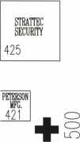

|  |  |  |  |
| --- | --- | --- | --- |
| Schwab | |  | LOCKSMITH 527 LEDGER |
| 527 |  |  |
| ZIPF | dCL |  | |
| LOCK CO. |  | |
| 525 | 624 | |  |
| ADAMS | CLARK | | COMPX |
| RITE | SECURITY | | SECURITY |
| 521 | 620 | CD | 621 |

|  |  |
| --- | --- |
| ASP | PRO- |
| INC, | LOK |
| 725 | 824 |

|  |  |
| --- | --- |
| ADESCO | ~acceSs~~ |
| SAFE | HARDWARE |
| 827 | 926 |
| COMMERCIAL | |
| 825 | VAN |

|  |  |
| --- | --- |
| FIREKING 4^5 SECURITY | |
| LAB | ESP |
| SECURITY | LOCK |
| 411 | 510 |
| SECURITY | o |
| DOOR  CONTROLS  407 | w |

|  |  |  |  |  |
| --- | --- | --- | --- | --- |
| YALE SECURITY |  |  |  | U.S. LOCK |
| GROUP INC, |  |  |  | CORP. |
| 201 |  | 301 |  | 401 |

|  |  |  |  |  |
| --- | --- | --- | --- | --- |
| DON-JO  511 | 610 | IR SECURITY  & Safety | IR | MIDWEST  808 |
| DOORKING  509 | 608 |
| BLACKHAWK  507 | 606 |  | SECURITY k SAFETY | PROF. BUSN, PRODUCTS 806 |
|  |  |  |  | PDQ |
| Sargent | 604 |  |  | 804 |
| k |  | ir Security |  |  |
| GREENLEAF | 602 | & Safety |  | AMERICAN |
|  |  |  |  | LOCK |
| 501 | 600 | 601 | 701 | 800 |

<

|  |  |
| --- | --- |
| SECUR1TECH  GROUP  811 | ARCHITECTUR  CONTROL  910 |
| Savta  809 | CROW  ELECTRONIC  908 |
| DUGMORE 807 k DUNCAN | |

The only gamble is staying home.



Keynotes • June 2003

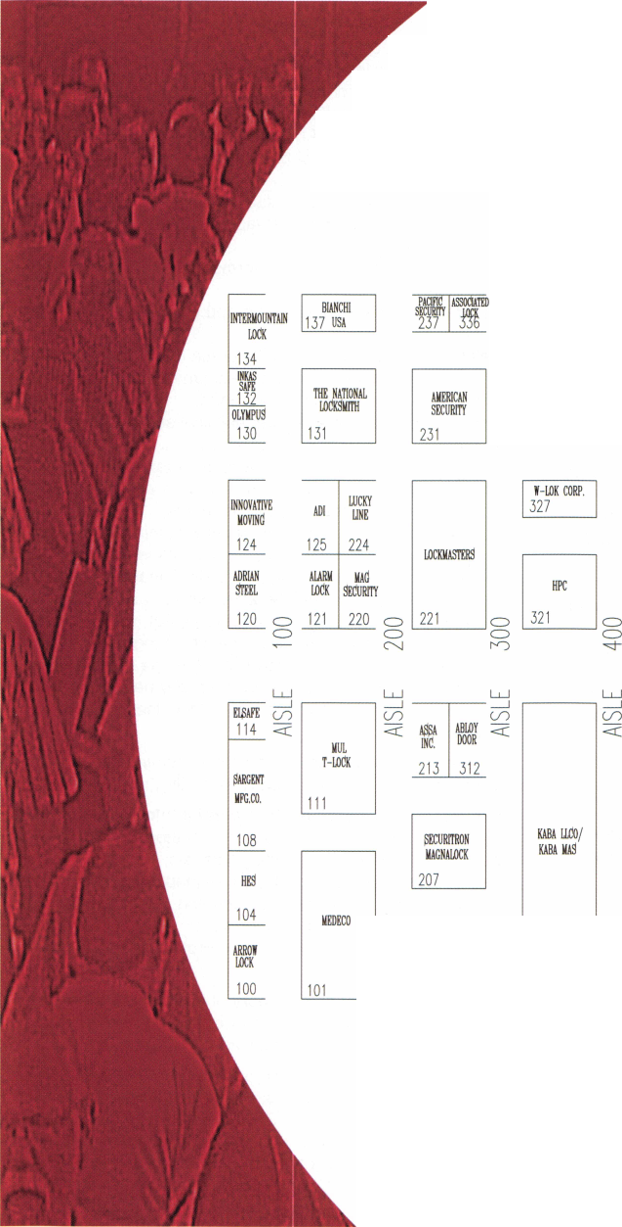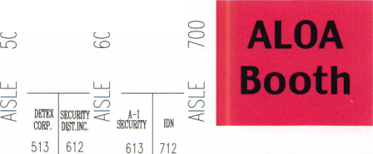

LAS VEGAS, NEVADA

ALOA 2003

* ♦ * **t**

|  |  |
| --- | --- |
| ROFU  927 | MUSTANG  COMPANY  1026 |
| IARKAR | MAIN'S  LOCK  1024 |
| PFAFTENHAIN |
| 923 | 1022 |
| MARKS  921 | SUPRA  PRODUCTS  1020 § |

SECURITY

1027

|  |  |
| --- | --- |
|  | CROSS  COUNTRY AUTO |
| HldH | 1122 |
| TECH | BUI DOC |
| 1021 | 1120 g |

|  |  |  |  |  |
| --- | --- | --- | --- | --- |
| INfL  ECTRONICS  937 | L0CKT00L3 NATIONAL 1037 | BDHHI  1136 1137 | 1236 1237 | CIA  RECRUITMENT  1336 |
| IREVO  INC.  933 | AUTO LOCK  1034 1035 | 1134 1135 | 1234 1235 | 1334 |
| INSTITUTIONAL  LOCKSMITH  1032 ® | 1132 1133 | 1 Q-zo “BA  1232 iisa | 1332 |
| A&B  SAFE  931 | SECURA HARDWARE  KEY  1030 1031 | HURD BYTE  1130 1131 | HAWLEY  LOCK  1230 1231 | SJ HOPE PRODUCTS  1330 |

|  |  |  |  |  |
| --- | --- | --- | --- | --- |
| RODMAN | MMF | KLA$Y | SECURE UR HOME | PHI |
| 1126 | 1127 | 1226 | 1227 | 1326 |

CD

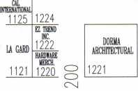

1337

1335

C VE INC.

1331

1327

MONARCH

|  |  |  |
| --- | --- | --- |
| THERFORD  ONTROLS  915 | Camden  1014 | GO  < |
| i$TATE |  |  |
| 913 | BURG |  |
|  | WACHTER |  |
| ABUS  LOCK | 1008 |  |
|  | OMAHA |  |
| 907 | 1006 |  |

|  |  |  |
| --- | --- | --- |
| STRONG  ARM  1015 | —i MDS  major cn im  MFG <rr | KUSTOM  KEY  1212 |
| PHOENIX  SAFE  1011 | KSP  1112 1113 |
| pau/aii AFFILIATED  lAM/AM CENTRAL  1110 1111 | ALL 6  LOCK  1210 |
| PLS  GROUP  1009 | SOUTHWEST CHINROSE  SPECIALTY INTL  1108 602 | JACKSON  1206 |
| KEEDEX  1007 | SUN RA-LOCK  SAFES MFG. CO.  1106 1107 |

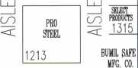

1311

|  |  |  |
| --- | --- | --- |
| HOME-  OWNERS  1209 | TOWNSTEEL  INC.  1308 | NEWPORT  PRECISION  1309 |
| CORPORATE | 1306 | 1307 |
| CAFE  1205 |  | 1305 |
| PATEL  1203 | 1302 | ULTRA |
| MAXTECH AMERICA INC.  1201 | 1-800-  LOCKSMTTH  1300 | UFT  1301 |

Exhibitor Booth #

1-800-LOCKSMITH 1300

A & B Safe Corporation 931

A-1 Security Mfg. Corp 613

Aable Locksmiths 1321

Abloy Door Security 312

Abus Lock Company 907

Access Hardware Supply 926

Accredited Lock Supply 830

Adams Rite Mfg. Company 521

Adesco Safe Mfg. Company/

Star Safe and Alarm 827

ADI, Inc 125

Adrian Steel Company 120

Affiliated Central, Inc 1111

Alarm Lock Systems, Inc. - Napco 121

All 5 Lock 1210

Allstate Insurance Company 913

ALOA 723

American Eagle Lock Co 630

American Lock Company 800

American Security Products 231

Architectural Control Systems 910

Armadillo Firearm Security Products 835

Arrow Lock 100

Associated Lock & Supply 336

ASP, Inc 725

ASSA Inc 213

Bad Dog Tools 1120

BDHHI 1137

Bianchi USA, Inc 137

Blackhawk Products 507

Burg-Wachter 1008

Bumil Safe Manufacturing 1311

Byte Brothers, Inc 1131

Cal International 1125

Cam/AM Door Hardware 1110

Camden Door Controls 1014

CCL Security Products 624

Chinrose International 602

CIA Recruitement Center 1336

Clark Security Products 620

Commercial Van Interiors 825

Compx Security Products 621

Corporate Safe Specialists 1205

Cross Country Automotive Service 1122

Crow Electronic Engineering Inc 908

CVE, Inc 1331

Defiant Safe Co. /ARFE 632

DETEX Corporation 513

Direct Security Supply, Inc 1027

Don-Jo Manufacturing Inc 511

Doorking 509

Dorma Architectural Hardware 1221

Dugmore and Duncan, Inc 807

Eclipse Ind 537

ELF 932

Elsafe 114

ESP Lock Products Inc 510

E-Z Trend, Inc 1222

FireKing Security Products 415

H.L.FIake 734

Framon Mfg. Company, Inc 635

Gardall Safe Corporation 435

Hardware Merchandisers, Inc 1220

Hawley Lock 1230

HES, Inc 104

High Tech Tools 1021

Homeowners Marketing Services 1209

Howard Keys 930

HPC, Inc 321

Hurd Corporation 1130

IDN Corporation 712

International Electronics 937

Inkas Safe Mfg 132

Innovative Moving Systems, Inc 124

Institutional Locksmiths Association 1032

Intermountain Lock and Key 134

iRevo.Inc 933

IR Security & Safety 601

Jackson Corporation 1206

Jet Hardware Mfg. Co 1031

Kaba llco/Kaba Mas 301

Keedex Manufacturing 1007

Keyless Ride 731

Keylights 535

Klassy Keys, Inc 1226

KSP 1113

Kustom Key 1212

La Gard Inc 1121

LAB Security 411

Lockmasters, Inc 221

Locksmith Ledger International 627

Locktools 1037

Lucky Line Products, Inc 224

MAG Security 220

MKM Lock 834

Major Manufacturing, Inc 1112

Main's Lock Supply 1024

Markar Products Inc 923

MARKS, U.S.A 921

Master Lock Company 531

Maxtech America, Inc 1201

MBA-USA, Inc 1231

MDS Incorporated 1115

Medeco 101

Midwest Wholesale Hardware 808

MMF Industries 1127

Monarch Coin & Security Inc 1325

Mustang Company 1026

Mul-T-Lock USA, Inc Ill

National Auto Lock 1034

Mutual Safe Company, Inc 337

Newport Precision Stampings 1309

Nostalgia

Olympus Lock Company 130

Omaha Wholesale Hardware 1006

OSI Security Devices 534

Pacific Security Products 237

Patel, Hitesh 1203

PDQ Manufacturing 804

Peterson Manufacturing 421

PHI Enterprises, Inc 1326

Pfaffenhain-North America 1022

Phoenix Safe International 1011

PLS Group 1009

Prazi, USA 600

Pro Steel 1213

PRO-LOK 824

Professional Business Products 806

RA-Lock Co 1107

Rodman & Company 1126

ROFU International Corp 927

Rutherford Controls Inc. - RCI 915

SAVTA 809

SJ Hope Products 1330

Sargent & Greenleaf, Inc 501

SARGENT Manufacturing Company 108

Schwab Corp 527

Secura Key 1030

Secure-Ur-Home 1227

Securitech Group, Inc 811

Securitron Magnalock Corp 207

Security Distributors Inc 612

Security Door Controls 407

Security Lock Distributors 631

Select Products Limited 1315

Senior Technologies, Inc 1327

Southwest Specialty Products 1108

Speedypik 831

SNA, Inc 934

STRATTEC Security Corp 425

Strong Arm Security, Inc 1015

Sun Safes Mfg 1106

Supra Products, Inc 1020

The National Locksmith 131

TimeMaster, Inc 837

Townsteel Incorporated 1308

U.S. Lock Corp 401

Ultra Lift 1301

Victor e-lok 836

Videx 431

W-Lok Corp 327

Wilco Supply 536

Yale Security Group, Inc 201

Zipf Lock Co 525

Keynotes • June 2003

Diebold

MONEY COMPARTMENT DOOR

By Merritt Perkins, RL

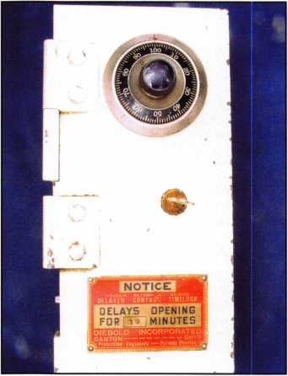

Photo I This is the door to the money compartment inside a Diebold burglary resistant safe. The door is 6 inches wide by 12 1/2 inches high with the dial of the combination lock near the top. In the center is a key operat­ed lever tumbler lock. Near the bottom is a sign stating that there is a 15-minute time delay after the combination has been dialed before the door can be opened. If the dial is not turned to withdraw the bolt within three minutes after the 15 minutes expires, it will lock again. The left-hand reverse bevel door is made of one- inch thick steel. The diagonal dimension of the door width is slightly greater than the width of the opening, so even though the hinge knuckles are cut off, it will not swing out of the opening.

|  |  |  |
| --- | --- | --- |
| N) *83^^**} |  | >  | |
| M | \ | (  k |

Photo 2 This is the back of the door with Delayed Action time (DAT) attached to the back of the combination lock. A window in the DAT case allows observa­tion of two disks, half red and half white, which rotate when the dual timers are running. If one timer stops, the other timer will unlock the lock. A sheet metal cover over the key-operated lock and relocking device keeps the contents of the compartment out of contact with them.

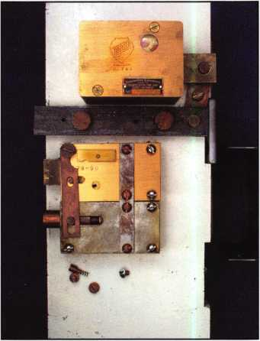

Photo 3 This is a view of the key-operated lock and relocking device with the cover removed.

If the nose of this lock is driven into the door, the link will be driven off the pin in the side of the relocker bolt and allow a spring to extend the bolt.

A groove in the bolt will then be opposite a hole in the bottom of the case where a spring will push a pin into the groove to pre­vent the bolt being pushed back into the case. The picture shows the pin, spring, accompanying screws and threaded retaining cap removed from the relocker.

Keynotes • June 2003

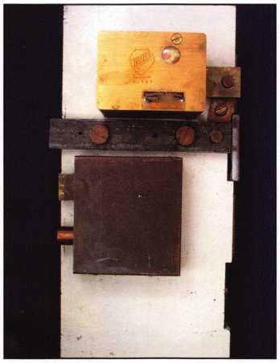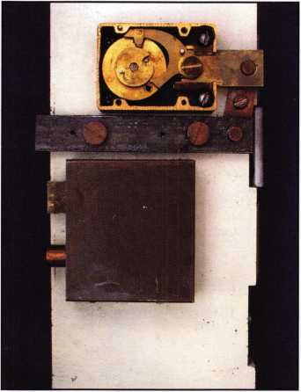

Photo 4 The inside of the door with the DAT removed from the combination lock. Linkage con­nects the lock bolt to the door bolt. This locks the door on the opposite side from the combina­tion lock bolt. The nose of the combination lock lever rests on the circumference of the drive cam. A lever spring holds the lever in contact with the cam.

The end of the lever rests against the lever stop on the inside of the case, which prevents it from with­drawing the bolt. The spline key is cut off flush with the end of the spindle, leaving no way to remove it. If the spline key extended beyond the end of the spindle, it would interfere with the time lock. A pin extends from the cam to engage the flat side of a disk on the timer to wind the time lock. A pin from the combi­nation lock lever goes in a slot in a disk on the timer, which keeps the bolt from being withdrawn until the disk can rotate.

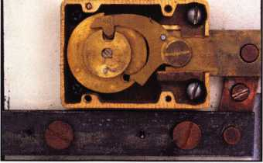

Photo 5 A close-up view show­ing the nose of the lever dropped into the gate in the drive cam while the fence attached to the back of the lever has dropped into the gates of all three wheels. The change key hole in the wheel, square with one flat corner, is on the lower right. The part of the lever next to the change key hole rests against the shoulder of the change key to hold the lever up out of the notch in the cam to allow the dial to be turned to set the combination while the wheels are unlocked. The change key holds the outer part of the wheel tumblers in position while the inner part of the wheel with the drive pins and flies (if any) are free to turn. After the new com­bination is dialed, the change key is turned to lock the outer and inner parts together and removed and the combination is changed. Of course, the new combination should be tried several times to be sure that it is working right before the door is closed.

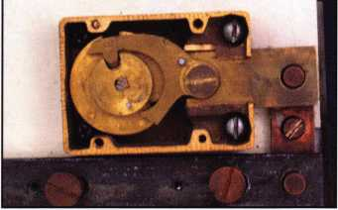

Photo 6 The bolt withdrawn with the lever below the boss.

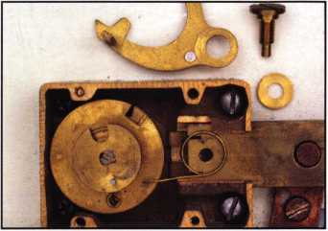

Photo 7 The lever, lever screw and washer, all removed, and with the lever spring in place.

The washer goes inside the spring and below the lever. The tip of the pivot screw fits into a recess in the lock case and limits the distance that the lock bolt can move. Putting the lever and spring together can be a frustrat­ing experience. It is difficult to put the parts together and get the spring in place. The end of the spring that is bent down goes into a slot in the bolt.

Keynotes • June 2003

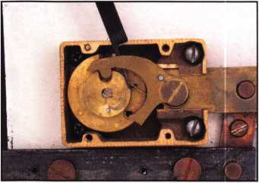

Photo 8 The lever screw is loose and the pivot end of the lever is held down to keep the spring around the washer, and from getting between the lever and the washer. A tool (a lifter for pin tumblers .015 inches thick) is inserted under the lever and hooked onto the spring. A lock pick would probably work.

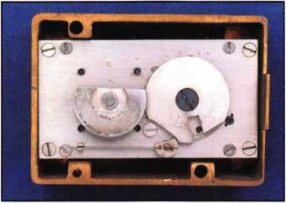

Photo IO The timer mecha­nism in its brass case. The disk wheel with the flat side is turned by a pin on the combination lock cam to wind the timer. The pin on the combination lock lever fits in the slot in the disk, which is kept from turning by the detent with a flat side and a flat steel spring staked into a slot in it.

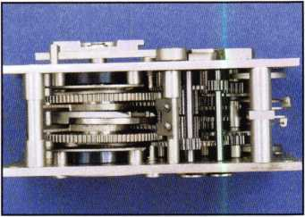

Photo 12 A side view of the dual timer with the detent shaft in the center. Flaps on the detent shaft are actuated by the clock cams that rotate with the large gears. The clock is not wound.

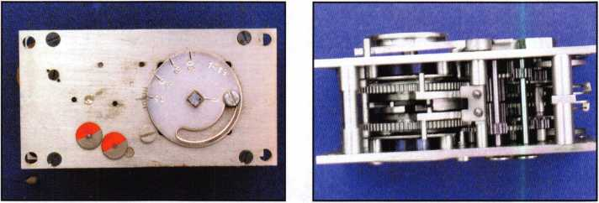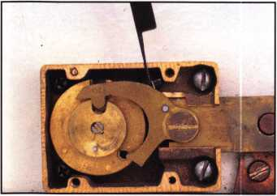

Photo 9 The spring is pulled out from under the lever and is ready to hook over the lever.

The nose of the lever needs to be in the gate in the drive cam so that the lever has dropped down to leave enough room between the top of the lever and the lock case for the hook on the spring to pass and hook over the top of the lever. Now the lever screw can be tightened.

Photo II The mechanism removed from the case showing the two disks that rotate while the timer is running and the adjustment disk to set the time delay. The graduation marks range from 15 to 30 minutes, but the extreme adjustment range is 14 to 36 minutes.

Photo 13 The high part of the cams that will unlock the detent contact the flaps on the detent shaft and turn the shaft opposite the unlocking direction to get past them, leaving the bolt locked.



Keynotes • June 2003

**You're Safe with SNA**

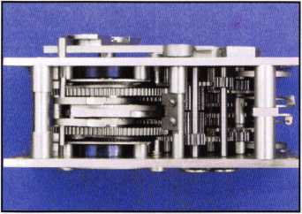

Photo 14 The DAT is being wound; the high parts of the unlocking cams are slightly to the left of the center of the gears.

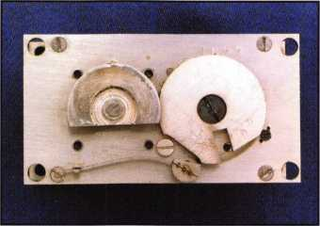

Photo 17 The detent has turned so that the slotted disk can pass the detent to allow it to turn so that the bolt can be withdrawn. (Compare to photo 10.)

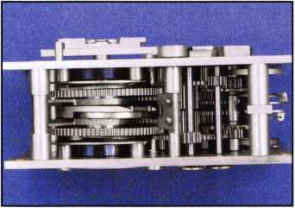

Photo 15 The DAT is wound. The safe dial no longer turns hard. The combination can be dialed.

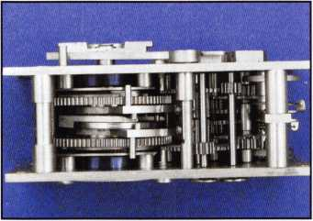

Photo 16 The time has expired and the high part of the cams have turned the flaps on the detent shaft in the unlocking direction. If one part of the timer stops, the cam of the other part will contact one of the flaps and turn the detent shaft to unlock it.

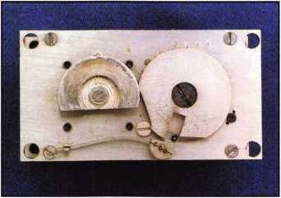

Photo 18 The slotted disk is turned part way so that the com­bination lock bolt is partly retracted. The lock is unlocked.

**Widest Selection**

**at the Best Prices**

**Meet us at the ALOA Security Expo 2003!**

Modern and tough-built, our safes have superior quality and a better price. Offer your customers more - from under­counter safes to depositories to burglar and fireproof composite safes. We have the widest selection.

For a catalog or to place an order call 1.800.421.0381

**S.N.A, Inc.**

Keynotes • June 2003

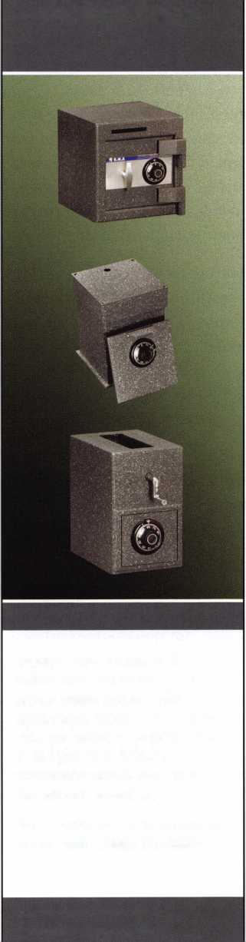

Profile of:

Pearl Technical Sales Inc.

This full-line fastener and hardware supply company was established by Larry Pearl in 1991. Having been in the fastener industry since 1977, Larry was looking to establish a different kind of fastener company, one that would forge long-term alliances with the customer base, and work with their production and planning depart­ments almost in a consultant capacity, as well as the purchasing departments.

Having grown over the years to service companies in the OEM, medical, automotive, electronics, construc­tion, and military fields, Larry has seen his vision of long-term commitments blossom. In fact, the only cus­tomers that have left the Pearl Technical Sales Company have been purchased by other companies, or moved overseas.

Pearl Technical Sales has seen a need in the construc­tion and service industries for a source for stock or cus­tom Sex Bolts, delivered quickly, and without a large minimum order.

Sex Bolts, a semi standard item used to fasten many components, including door hardware, railings, cabi­nets, signs, outdoor equipment, marine and boat equip­ment, and thousands of other items, have been tradi­tionally very hard to find from stock.

Pearl Technical Sales has partnered with Accurate Manufactured Products Group, one of the largest man­ufacturers of standard and special Sex Bolts and fasten­ing solutions. Accurate has been manufacturing Sex Bolts, Binding Posts, Grommet Nuts, Connecting Bolts, Barrel Bolts, and other fastening solutions, since 1994. They produce the largest line of standard sex bolt solu­tions in the world.

Pearl Technical Sales now has a full line of Sex Bolts in stock ready for same-day shipment, with a low $15 mini­mum order. In-stock items include steel, stainless, brass, and aluminum sex bolts and binding posts, in many dif­ferent head styles and configurations. Security and dec­orative heads are available, as well as many lengths and diameters. Architectural finishes are also in stock.

On of the special advantages that Pearl Technical Sales can offer is the ability to use Accurate Manufactured Products Specials program. This revolutionary program offers small quantity custom runs, with a turnaround of 10 days or less. For as few as 50 pieces, Pearl Technical Sales can offer a complete custom capability. Custom heads, sizes, and materials are offered. Accurate has spe­cialized CNC Machinery specially designed to handle these requests in a speedy and cost effective manner. This program has been a huge help to many companies involved in construction projects with a tight schedule, and also a perfect solution those jobs that have been shorted the correct hardware count!

To summarize, Pearl Technical Sales is looking to become well known as the place to go for Sex Bolt solu­tions, especially in the security and locksmith fields. From offering a custom design and build service unique in the world, to putting together assortment kits for Locksmiths, Pearl Technical Sales stands ready to serve. Just call them to unlock the door on superior product and services!

Pearl Technical Sales can be reached at 631-698-7173 for phone, and their fax number is 631-736-5467.

Accurate

Manufactured Products Group

65 East Bethpage Road - Plainview, New York 11803

phone: 516 752-3100 fax: 516 752-3128

url: [www.accuratemfg.com](http://www.accuratemfg.com) email: [sales@ampg.com](mailto:sales@ampg.com)

Keynotes • June 2003

**Fastening Solutions**

for Locksmiths

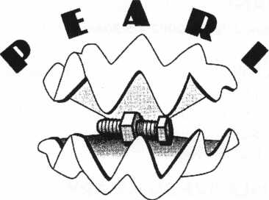

TECHNICAL SALE!, INC.

**Pearl Technical Sales**

***featuring sex bolt solutions from***

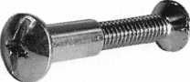

Sex Bolt Hardware and Fasteners - In stock for immediate shipment.

• Sex Bolts - Standard and Custom Sizes • Custom Service

* 50 Piece Minimum custom order
* Quick TurnAround
* CNC manufactured, Top Quality
* Brass, Stainless Steel, and Steel materials
* Architectural finishes
* Sex Bolt Assortment Kits
* Barrel Bolts
* Binding Posts
* Connecting Bolts

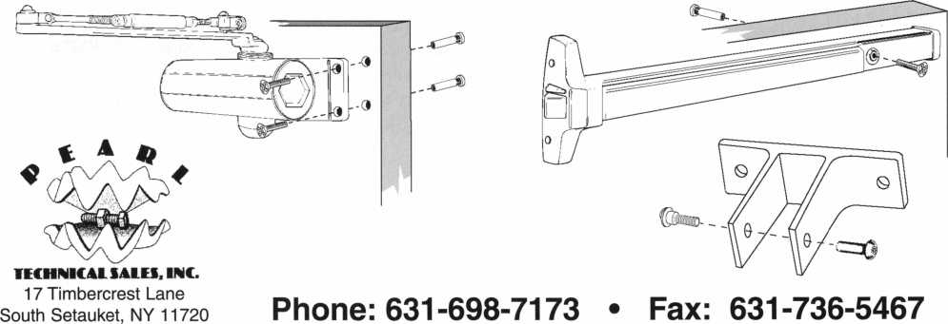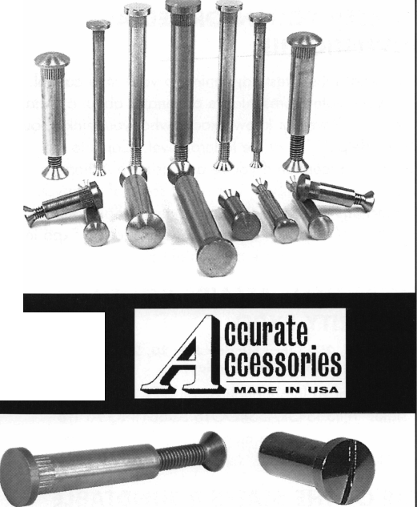

NUMEROUS LEGISLATIVE ACTIVITIES WILL KEEP YOU INFORMED AT CONVENTION!!!

Find out what's the latest happening in your state capitol. Contact your state representative or senator about a certain bill. Let your Governor know exactly what you think about him/her. Help ALOA at the federal level. Come to the "Thank You!" reception if you're a Legislative Action Network Council member. This is just some of what you can expect this year from the Government Affairs depart­ment at the ALOA 2003 Convention and Security Expo in Las Vegas. Here are some of the highlights:

GOVERNMENT AFFAIRS BOOTH AT SECURITY EXPO

Friday July 18, 2003 thru Sunday July 20, 2003 Noon to 5pm (10am to 2pm Sunday)

On site we'll have information on all bills, and legislation in your state. THIS IS GRASSROOTS LOBBYING AT ITS FINEST! Free Convention merchandise for Legislative Action Network members.

STATE OF THE STATES ROUNDTABLE

Friday July 18, 2003 • 6:30pm to 8:00pm

This meeting is designed as a forum for ALOA chapters and local/state regional locksmith associations to share informa­tion about the state of locksmithing in their region and a dynamic way to share ideas. Primarily for the Chairman, President and Legislative representative from each organiza­tion, all locksmiths are encouraged to participate. This is the perfect opportunity to learn about what's going on in the industry across the nation.

LEGISLATIVE ACTION NETWORK "THANK YOU!" RECEPTION

Saturday, July 19, 2003 • 5:30pm to 6:30pm

As a way to say "THANK YOU" for all your hard work, ALOA is throwing a party for all members of the Legislative Action Network Council members (donations of $100 or more to the Legislative Fund). This invite-only event will be the perfect way to celebrate the MANY legislative victories ALOA had this year!

LEGISLATIVE SUMMARY

The Associated Locksmiths of America, Inc. (ALOA) worked very hard this year on legislation affecting the security industry at the state and federal levels. We actively worked on 16 bills in 14 states plus one federal bill.

There was only one alarm licensing bill introduced this year (Mississippi), which never made it out of committee. In Illinois the Private Detective, Private Alarm, Private Security and Locksmith Act is going through changes to update the law. Again, in Minnesota they introduced a bill that requires criminal background checks for "electronic security system companies" which is further defined as "burglary detection, access control, or closed circuit television." Missouri introduced an Electrician's Licensing bill that includes low-voltage. Louisiana and Tennessee have both introduced locksmith licensing laws.

We have also been working with the Coalition for Auto Repair Equality (CARE) and Rep. Joe Barton (R-TX) to pres­sure the auto manufacturers into providing information to originate keys, or else have the "Motor Vehicle Owners' Right to Repair Act" introduced. Rep. Barton has specifical­ly asked that information for locksmiths be includes on what the manufacturers provide to the aftermarket. We have also been in contact with Rep. Brad Sherman's (D-CA) office about introducing a bill that specifically requires manufac­turers to supply information to originate keys using scan tools to the consumer or his/her agent.

Keynotes • June 2003

CONNECTICUT SB 14

Requires the licensing of locksmiths. Failed Joint Favorable deadline.

ILLINOIS SB487

Revises the Private Detective, Private Alarm, Private Security and Locksmith Act. To Committee on Executive.

INDIANA HB1946

Establishes a voluntary registration program for locksmiths who pass a background check. To Committee on Commerce.

LOUISIANA HB310

Provides for the licensure of locksmiths and requires a license to install and maintain access control devices and closed circuit television alarm systems. Introduced.

MINNESOTA HB773/SB797

Requires that employees of electronic security system com­panies, undergo criminal history background checks. To Committee on Ways and Means.

MISSISSIPPI SB2609

Licensing of alarm industry. Alarm definition tied it to a monitored system. Died in Committee.

MISSOURI SB680

Establishes a licensing board to regulate electrical contrac­tors, which includes low-voltage. In Committee on Financial and Governmental Organizations, Veterans Affairs and Elections.

NEVADA SB39

Requires landlord to change entry locks of dwelling unit before delivering possession of dwelling unit to new tenant. To Senate Committee on Judiciary.

NEW YORK AB2646

Establishes security requirements to be fulfilled by owners of multiple dwelling units including deadbolt locks. To Committee on Housing.

NEW YORK AB5024

Provides that class A multiple dwellings having 8 or more apartments erected or converted prior to 1968, must have automatic self-closing and self-locking doors at every entrance. To Committee on Housing.

NORTH CAROLINA SB655

Allows the licensing Board to conduct criminal history record checks. To Committee on Commerce.

NORTH DAKOTA HB1159

Relates to the jurisdiction of the private investigative and security board. Gives vague definition on what constitutes "security services" Died in committee.

SOUTH CAROLINA SB 186

Provides certain instances in which dead bolt locks requir­ing a key for operation on both sides may be used on exit doors. To Committee on Judiciary.

TENNESSEE HB274/SB656

Relates to locksmith licensing. To Committee on Commerce.

TENNNSEE SB188

Requires that all alarm system contractor employees take and successfully complete the National Burglar and Fire Alarm Association Level 1 training. To Committee on Commerce, Labor and Agriculture.

TEXAS HB2594

Relates to the voluntary registration of locksmiths. To Committee on Licensing and Administrative Procedures.

JOIN THE LEGISLATIVE ACTION NETWORK TODAY!

As we continue to expand our resources and become more competitive in the legislative arena, we need the monetary resources to match our successes. You can help with as lit­tle as $24.95 to the Legislative Fund. This is only the mini­mum that we are asking, and encourage you to give more if you can. Those that contribute will be given a Legislative Action Network Member kit to use in their grass roots efforts. Members who donate $100 or more become Legislative Action Network Council members, and enjoy the following extra benefits: a reserved place of distinction on the special LAN Council; Discounts on ALOA bookstore items; 10 % rebate on all ACE classes; Complimentary Legislative Convention merchandise. Join today online at [www.aloa.org/news/lan.htm](http://www.aloa.org/news/lan.htm).



Keynotes • June 2003



EMPLOYMENT

HELP WANTED

Emory is one of the five largest private employers in the Atlanta metro area and the largest employer in Dekalb County. The University is admired worldwide for academic, patient care, research and technological excellence. As an Emory employee, you are part of a community which values diversity, education, training, and personal development. Creativity and innovative ideas are nourished and rewarded. We invite you to share in a unique culture of education, research and health care.

We currently have a great opportunity for a Supervisor, Security Systems in our Security Shop. They will Provide lock­smith, alarms, control systems and security system services including installing, repairing, inspecting, and recombination mechanical, electro-mechanical, electronic locking and moni­toring devices and door hardware. Performs diagnostic tests on digital, key pad and card-locking, and other electronic locking systems for the University.

MINIMUM QUALIFICATIONS: High school diploma or equivalent. Five years combination locksmith and electronics/security systems experience, including two years supervisor experience. Thorough journeyman level knowledge and skills in mechanical, electro-mechanical, electronic locking and monitoring devices and door hardware. Journeyman level skill in maintenance and repair procedures including pre­ventive maintenance, breakdown repair and troubleshooting, construction, installation and fabrication techniques typical in trade; perform mathematical computations of trade.

Knowledge of ADA specifications and proper use and mainte­nance of hand and power tools, test equipment and electron­ics equipment related to job functions. Valid Georgia driver's license and insurable driving record. Some positions within this classification may require the ability to lift 50 pounds and to bend, stoop and twist.

Departmental Information/Preferred Qualifications: Ideal candidate will have a high degree of organizational, commu­nication, customer service, and good leadership skills.

We offer competitive salaries and world-class benefits including major medical/dental/vision/life insurance, disabili­ty insurance, paid holidays/vacation, tuition assistance, a gen­erous employer matching 403(b) retirement plan and courtesy scholarships for family members and same-sex domestic part­ners. For more information about our benefits, please visit our website at: <http://emory.hr.emory.edu/benefits.nsf>

A career with Emory University affords a level of prestige and stability not found in many Atlanta Employers of Choice. We invite you to become a part of the Origins of Excellence!

Please submit your resume via (online from) the Emory Careers Website at emory.hr.emory.edu/careers.nsf or by mail at Emory University, 1762 Clifton Road, Atlanta, GA, 30322. Phone: 404.727.7611 Fax: 404.727.1922 Please reference Job posting 136542 when applying.

Emory University is an AA/EOE Employer

STOP LOOKING!!!!!

EXPERIENCED TECHNICIANS WANTED

Lock into your future now!

If you are experienced, intelligent, and desire a secure future, come join our team. We are a full service commercial/residential security service (locks,keys,safes,cctv,access control, door related hardware). We offer: sign on bonus, top wages, company vehicle, 401k, paid vacation, paid holidays, new uniforms, cross training, and job satisfaction.

We are looking for the best tech's, who are ready to be treated and compensated as professionals.

Bass Security Services, Inc.

Ph#216-755-1200 ex.#128

Fax#216-755-1220

E-MAIL / [rmesnick@bass-security.com](mailto:rmesnick@bass-security.com)

LOCKSMITH WANTED

In Beautiful Tennessee. We are growing in middle Tennessee. Need help in Commercial Alarms and Access control. Experienced or will train. Call "Ken" at Bearclaw Security & Locksmith. 1-866-446-1107 (toll free) or fax resume to 1-615-441-3196.

BUSINESS FOR SALE

BUSINESS FOR SALE

Locksmith glass and screen business located in fast growing NW Arizona between Kingman, AZ, and Laughlin, NV. Well- equipped 1995 Dodge van and leased shop on busy high­way. All equipment and inventory included. $48,900 takes all. Health demands retirement. Call (928) 565-2294 or e-mail at [lmburks@ctaz.com](mailto:lmburks@ctaz.com).

COMMERCIAL LOCK BUSINESS FOR SALE

Commercial locksmith company specializing in high tech, high security sales, service and installations is for sale. Business was established in 1978 and is located in the Inland Empire of Southern California. ASSA dealer with six keyways and most accounts are on the ASSA system. Residential and auto­motive are currently referred to others, so there is lots of room for expansion. Excellent high security addition to an existing lock business or instant income for a rookie or retiree. Retiring and moving to the northwest, so business is priced to sell fast! Call 909-29-8480 for details.

BUSINESS FOR SALE

Owner Retiring. Well-established business in central Ohio, est. 1965. Sale includes equipment, inventory, 2000 Dodge Ram 2500 van. Commercial and residential accounts. We are a Medeco Patriot dealer for the county and surrounding area. Call 419/562-4896, or write to: Wink's Lock and Safe •

113 W. Warren St. • Bucyrus, OH 44820

FOR SALE

Well-established lock shop, fully-equipped shop van. Hub city, serving all of northeastern Nevada. Same location for 20 years. Large commercial clientele. Great outdoor recreational area, hunting, fishing, etc. Elko Lock and Safe.

Call 775/738-3938, fax 775/738-2370.

FOR SALE

Overstock, New Von Duprin 33NL-OP, 33EO, E99K,

3347EO, 9947EO, CD3347TL, EPT-10, Von Duprin electric strike 621 1, 6233. Rixson mag hold 980,997 Locknetics 505. Please call for price. Kevin at 915-553-3145, or e-mail [reddog2501@excite.com](mailto:reddog2501@excite.com).

COMMERCIAL LOCK BUSINESS FOR SALE

Commercial locksmith company specializing in high tech, high security sales, service and installations is for sale. Business was established in 1978 and is located in the Inland Empire of Southern California. ASSA dealer with six keyways and most accounts are on the ASSA system. Residential and auto­motive are currently referred to others, so there is lots of room for expansion. Excellent high security addition to an existing lock business or instant income for a rookie or retiree. Retiring and moving to the northwest, so business is priced to sell fast! Call 909-295-8480 for details.

LOCKSMITH MOBILE SERVICE FOR SALE

Established mobile locksmith service in the Bay Area. Specializing in automotive and residential with some light commercial work. Territory covered is Fremont, Hayward,

Union City and Castro Valley in California. Three trucks are currently being used in the area. Fully-equipped with tools and key machines. Professionally labeled vehicles that are well kept. This territory averages a gross in sales per year of around a half a million dollars.

We are looking for a qualified individual that is self motivated to take over operations. Willing to sell for a rock-bottom price to the right individual. Desperate to sell immediately. Please call 888/815-6257 for details. Robert Bradley, President, Locksmith Central

Classified Advertising Policy

Classified advertising space is provided free of charge to ALOA members, and for a fee of $.60 per word, $ 15 minimum for non-members. Classified ads may be used to advertise used  
merchandise and overstocked items for sale, "wanted to buy" items, business opportunities, employment opportunities/positions wanted and the like. Members or non-members wishing to  
advertise services or new merchandise for sale may purchase a "Commercial Classified Ad," for a fee of $1.30 per word, with a minimum of $40. Each ad will run for two issues. For  
blind boxes there is a $5 charge to members and non-members. All ads must be submitted in writing to the ALOA office by the fifteenth of the month, two months prior to issue date. Send  
to Keynotes Classifieds, 3003 Live Oak St., Dallas TX 75204-6186. ALOA reserves the right to refuse any classified advertisement that it deems inappropriate according to the stated pur-  
pose of the classified advertising section.

m

Keynotes • June 2003

BUSINESS FOR SALE

Middle Tennessee area for 25 years. Moved from mall after  
20 years. Completely stocked '95 Chevy van with metal and  
wooden cabinets. Honda 650-watt generator and key  
machines and several Curtis clippers. Inventory includes  
enough stock to open storefront operation, with two computers  
and all codes installed. Call 931/686-8187. Ted or Louise.

FOR SALE

Mobile and home-based locksmith business. Nice equipment  
and many extras. $45,000, with '97 Astro van, $35,000  
without van. Call or write Triple A Locksmith Shop at  
309/852-0450, or PO Box, 537, Kewanee, IL, 61443.

FOR SALE

Lock shop for sale in west central Wisconsin. Fixtures, tools,  
inventory, and established clientele, with or without building.  
Profitable second business included. E-mail: [lockshop@safen-  
lock.com](mailto:lockshop@safen-lock.com).



WANTED TO BUY/SELL

WHOLESALE SAFE DEPOSIT LOCKS

Allied, Diebold, Herrin, Hall & Mavin, llco, Lefabure, Mosler, Precission, S&G, Security Corp., Yale. Locks from early 1900s to current. Call or email for lock type and pricing sheet. Quantity discounts. Call WBI at (954)484-2404 or email: [sales@wbi.us](mailto:sales@wbi.us)

NEED CASH?

Have you recently sold your locksmith business, or are you selling it now? Are you carrying the financing? We can give you a lump sum of cash now for all or a portion of your remaining payments. RED OAK FUNDING. 630/483-0335, [www.redoakfunding.com](http://www.redoakfunding.com)

BUSINESS FOR SALE

Looking to relocate to sunny Arizona. Established in same location for over 14 years. Profitable Lock & Safe business with service and retail location. Good client base. Reasonably price to right person. E-mail inquiries to [Lockbizaz@aol.com](mailto:Lockbizaz@aol.com) or fax to (602) 870-8505.

Were Packing Them In

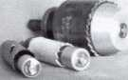

Hole Saw

Alignment

Guides

No More Plywood, "C" Clamps, or Jigs  
Needed to Over Bore Existing Holes

* Our Guides let you over bore existing holes that meas. 5/8”, 3/4" & 1-1/2" diameter
* They work on wood as well as metal
* Ttoo small sizes ideal for desks and cabinets
* Purchase in sets or individually
* Visa, MC, Amex, Discover
* MONEY-BACK GUARANTEE

Tri-City **Lock Company**

Daniel **D.** Mello, Owner-Locksmith  
Groveland, CA

209 962 4692 • 209 962 4910 FAX E-mail: [slmeUo@mlode.com](mailto:slmeUo@mlode.com) **[www.tricitylock.com](http://www.tricitylock.com)**

2003 Pacific locksmith  
Conference and  
Security Expo

Glasses, Trade Show, Seminars, Fellowship  
Oct. 14-18

Portland, OR • Holiday Inn at the Airport Contact: Dan Cunningham (Registration)

(FAX) 360-835-1191 • E-Mall [danslocksafe@iuno.com](mailto:danslocksafe@iuno.com)

Visit me pia web site for  
more information:  
[www.pla-pro.org](http://www.pla-pro.org)

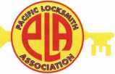

Keynotes • June 2003



Distributor

ADI Inc

Phone: 631-692-1000 Fax: 631-692-3011

Accredited Lock Supply Co

Phone: 201-865-5015 Fax: 201-865-0030 [www.acclock.com](http://www.acclock.com)

Ace Lock & Security Supply

Phone: 908-688-7666 Fax: 908-688-2442 [www.acelock.com](http://www.acelock.com)

Action Hardware Inc

Phone: 800-662-6695 Fax: 800-930-2329

Andrews Wholesale Lock Supply

Phone: 717-272-7422 Fax: 717-274-8659 [www.andrewslock.com](http://www.andrewslock.com)

Boyle & Chase Inc

Phone: 800-325-2530 Fax: 800-205-3500 [www.boyleandchase.com](http://www.boyleandchase.com)

Chinrose International

Phone: 503-357-7553 Fax: 503-357-5522 [www.chinrose.com](http://www.chinrose.com)

Clark Security Products

Phone: 800-854-2088 Fax: 619-974-5284 [www.clarksecurity.com](http://www.clarksecurity.com)

Cook's Building Specialties

Phone: 505-883-5701 Fax: 505-883-5704

Dire's Lock & Key Company

Phone: 303-294-0176 Fax: 303-294-0198

Direct Security Supply; Inc.

Phone: 800-252-5757 Fax: 800-452-8600

Doyle Security Products

Phone: 800-333-6953 Fax: 612-521-0166 [www.doylesecurity.com](http://www.doylesecurity.com)

Dugmore and Duncan, Inc.

Phone: 888-384-6673 Fax: 888-329-3846

E. L. Reinhardt Co., Inc.

Phone: 800-328-131 1 Fax: 651-481-0166 [www.elreinhardt.com](http://www.elreinhardt.com)

Ewert Wholesale Hardware

Phone: 800-451-0200 Fax: 708-597-0881

Fairway Supply, Inc.

Phone: 214-350-0021 Fax: 214-352-4299 [www.fairwaysupply.com](http://www.fairwaysupply.com)

Foley-Belsaw Company

Phone: 800-821-3452 Fax: 816-483-5010 [www.foley-belsaw.com](http://www.foley-belsaw.com)

Keynotes • June 2003



**associate**

members

Fried Brothers Inc.

Phone: 800-523-2924 Fax: 215-592-1255 [www.fbisecurity.com](http://www.fbisecurity.com)

H L Flake Co

Phone: 800-231-4105 Fax: 713-926-3399 [www.hlflake.com](http://www.hlflake.com)

H.S. & S. Wholesale Distrib.

Phone: 313-342-6777 Fax: 313-342-7580

Hans Johnsen Company

Phone: 214-879-1550 Fax: 214-879-1530 [www.hjc.com](http://www.hjc.com)

Hardware Agencies, Ltd.

Phone: 416-462-1921 [www.hardwareagencies.com](http://www.hardwareagencies.com)

IDN Incorporated

Phone: 817-421-5470 Fax: 817-421-5468 [www.idn-inc.com](http://www.idn-inc.com)

Intermountain Lock & Supply

Phone: 800-453-5386 Fax: 801-485-7205 [www.intermountainlock.com](http://www.intermountainlock.com)

Jo Van Distributors

Phone: 416-752-2238 Fax: 416-752-7282 [www.jovanlock.com](http://www.jovanlock.com)

KeylessRide

Phone: 877-619-3136 Fax: 409-216-5058 [www.keylessride.com](http://www.keylessride.com)

Lockmasters, Inc.

Phone: 859-885-6041 Fax: 859-885-7093 [www.lockmasters.com](http://www.lockmasters.com)

Locks Company

Phone: 800-288-0801 Fax: 305-949-3619

Locksmith Ledger International

Phone: 770-886-0800 Fax: 770-889-7703 [www.lledger.com](http://www.lledger.com)

M. Zion Company

Phone: 212-349-8677 Fax: 212-964-0495 [www.mzion.com](http://www.mzion.com)

McDonald Dash Locksmith Supp

Phone: 800-238-7541 Fax: 901-366-0005 [www.mcdonalddash.com](http://www.mcdonalddash.com)

McManus Locksmith Supply, In

Phone: 704-333-9112 Fax: 704-332-8664

Monaco Lock Co.

Phone: 800-526-6094 Fax: 800-845-5625 [www.monacolock.com](http://www.monacolock.com)

Omaha Wholesale Hardware

Phone: 800-238-4566 Fax: 402-444-1664 [www.omahawh.com](http://www.omahawh.com)

Phoenix Safe International LLC

Phone: 765-483-0954 Fax: 765-483-0962 [www.phoenixsafeusa.com](http://www.phoenixsafeusa.com)

Professional Business Products

Phone: 248-360-3979

Fax: 248-360-3982

[www.professionalbusinessproducts](http://www.professionalbusinessproducts).

RA-Lock Company

Phone: 972-775-6301 Fax: 972-775-6316 [www.ralock.com](http://www.ralock.com)

S J Hope Products

Phone: 702-260-7645 Fax: 702-837-1465

SNA Inc.

Phone: 678-206-0381 Fax: 678-206-0382 [www.sungil-safe.com](http://www.sungil-safe.com)

SecureRite.Com

Phone: 800-241-3930 Fax: 858-974-5269 [www.SecureRite.Corn](http://www.SecureRite.Corn)

Security House

Phone: 905-669-5300 Fax: 905-660-6313 [www.securityhouselock.com](http://www.securityhouselock.com)

Security Lock Distributors

Phone: 800-847-5625 Fax: 800-878-6400 [www.securadealer.com](http://www.securadealer.com)

Sentry Security Fasteners

Phone: 309-693-2800 Fax: 800-693-2872

Somerset Security Products

Phone: 800-881-5206 Fax: 800-206-9949

Southern Lock and Supply Co.

Phone: 727-541-5536 Fax: 727-544-8278 [www.southernlock.com](http://www.southernlock.com)

Stone & Berg Wholesale

Phone: 800-225-7405 Fax: 800-535-5625

The Locksmith Store Inc.

Phone: 847-364-5111 Fax: 847-364-5125 [www.locksmithstore.com](http://www.locksmithstore.com)

Timemaster Inc

Phone: 859-259-1 878 Fax: 859-255-0298 [www.time-master.com](http://www.time-master.com)

Top Notch Distributors, Inc.

Phone: 800-233-4210 Fax: 800-854-4146 www.4topnotch .com

Turn 10 Wholesale

Phone: 800-848-9790 Fax: 800-391-4553

U.S. Lock Corp.

Phone: 800-925-5000 Fax: 800-338-5625 [www.uslock.com](http://www.uslock.com)

Wilco Supply

Phone: 800-745-5450 Fax: 510-653-5397 [www.wilcosupply.com](http://www.wilcosupply.com)

Manufacturer

A & B Safe Corporation

Phone: 800-253-1267 Fax: 856-863-1208 [www.a-bsafecorp.com](http://www.a-bsafecorp.com)

ABUS Lock Company

Phone: 800-352-2287 Fax: 602-516-9934 [www.abus.com](http://www.abus.com)

Abloy Door Security

Phone: 800-465-5761 Fax: 514-335-0430 [www.abloy.com](http://www.abloy.com)

Adams Rite Mfg Company

Phone: 800-872-3267 Fax: 800-232-7329 [www.adamsrite.com](http://www.adamsrite.com)

Adesco Safe Mfg. Company

Phone: 800-694-9340 Fax: 562-408-6427 [www.adesco.com](http://www.adesco.com)

Adrian Steel Company

Phone: 800-677-2726 Fax: 517-265-5834 [www.adriansteel.com](http://www.adriansteel.com)

Alarm Lock Systems Inc.

Phone: 800-252-5625 Fax: 516-789-3383 [www.alarmlock.com](http://www.alarmlock.com)

All Five Tool Company, Inc.

Phone: 860-583-1691 Fax: 860-583-4516 [www.all5tool.com](http://www.all5tool.com)

American Lock Company

Phone: 708-534-2000 Fax: 708-534-0531 [www.armericanlock.com](http://www.armericanlock.com)

American Security Products

Phone: 909-685-9680X1083 Fax: 909-685-9685 [www.amsecusa.com](http://www.amsecusa.com)

BWD Automotive

Phone: 334-872-6524 Fax: 334-874-6011 [www.bwdautomotive.com](http://www.bwdautomotive.com)

Baldwin Hardware

Phone: 610-796-4012 Fax: 610-796-4493 [www.baldwinhardware.com](http://www.baldwinhardware.com)

Be-Tech Security Systems Ltd

Phone: 852-231-67447 www. be-tec h. com. h k

Bianchi USA, Inc.

Phone: 800-891-2118 Fax: 216-803-0202

Buddy Products

Phone: 800-886-8688 Fax: 312-733-8356 [www.buddyproducts.com](http://www.buddyproducts.com)

**associate**

members

COMPX Security Products

Phone: 864-297-6655 Fax: 864-297-9987 [www.nclnet.com](http://www.nclnet.com)

Curtis Industries, A Barnes Distr

Phone: 800-555-5397 Fax: 800-867-6020 [www.curtisindustries.com](http://www.curtisindustries.com)

D&D Technologies (USA), Inc

Phone: 714-677-1300X292 Fax: 714-677-1299 [www.ddtechusa.com](http://www.ddtechusa.com)

DETEX Corporation

Phone: 800-729-3839 Fax: 830-620-6711 [www.detex.com](http://www.detex.com)

DORMA Architectural Hardware

Phone: 717-336-3881 Fax: 717-336-3500 [www.dorma-usa.com](http://www.dorma-usa.com)

Don-Jo Manufacturing, Inc.

Phone: 978-422-3213 Fax: 978-422-3467 [www.don-jo.com](http://www.don-jo.com)

Door Controls International

Phone: 800-742-3634 Fax: 800-742-0410 [www.doorcontrols.com](http://www.doorcontrols.com)

ESP Lock Products Inc.

Phone: 978-562-3481 Fax: 978-562-9859

FireKing Security Products

Phone: 800-457-2424 Fax: 800-896-6606 [www.fireking.com](http://www.fireking.com)

HES, Inc

Phone: 623-582-4626 Fax: 623-582-4641 [www.hesinnovations.com](http://www.hesinnovations.com)

HPC, Inc.

Phone: 847-671-6280 Fax: 847-671-6343 [www.hpcworld.com](http://www.hpcworld.com)

Hongtai Lock Co Ltd

Phone: 137-238-1414 Fax: 208-793-3856

INTELLIKEY Corp.

Phone: 800-226-0703 Fax: 321-724-0811 [www.intellikey.com](http://www.intellikey.com)

Jet Hardware Mfg., Co.

Phone: 718-257-9600 Fax: 718-257-0973 [www.jetkeys.com](http://www.jetkeys.com)

KABA High Security Locks

Phone: 860-621-3601 Fax: 860-621-9727 [www.kabausa.com](http://www.kabausa.com)

KABA ILCO Corp.

Phone: 252-446-3321 Fax: 252-446-4702 [www.kaba-ilco.com](http://www.kaba-ilco.com)

KEY-BAK/West Coast Chain Mfg

Phone: 909-923-7800 Fax: 909-923-0024 [www.keybak.com](http://www.keybak.com)

Keri Systems Inc

Phone: 408-451-2520 Fax: 408-441-0309 [www.kerisys.com](http://www.kerisys.com)

Knaack Manufacturing Co.

Phone: 800-456-7865 Fax: 815-459-9097 [www.weatherguard.com](http://www.weatherguard.com)

LAB Security

Phone: 800-243-8242 Fax: 860-583-7838 [www.labpins.com](http://www.labpins.com)

LCN Closers/Div of Ingersoll

Phone: 815-875-3311 Fax: 815-879-1497 [www.lcnclosers.com](http://www.lcnclosers.com)

La Gard Inc.

Phone: 310-325-5670 Fax: 310-325-5615 [www.lagard.com](http://www.lagard.com)

Lucky Line Products, Inc.

Phone: 858-549-6699 Fax: 858-549-3241 [www.luckyline.com](http://www.luckyline.com)

M.A.G. Security

Phone: 714-891-5100 Fax: 714-892-6845 [www.magsecurity.com](http://www.magsecurity.com)

MARKS, U.S.A.

Phone: 516-225-5400 Fax: 516-225-6136 [www.marksusa.com](http://www.marksusa.com)

MARRAY ENTERPRISES

Phone: 408-970-0213 Fax: 408-970-8767 [www.marray.com](http://www.marray.com)

MCS Communication Systems

Phone: 450-444-2040X225 Fax: 450-444-4856 [www.mcscommunication.com](http://www.mcscommunication.com)

MMD, Inc.

Phone: 865-428-3611 Fax: 865-453-4136

MUL-T-LOCK USA, Inc

Phone: 800-562-351 1 Fax: 973-778-4007 [www.mul-t-lock.com](http://www.mul-t-lock.com)

Master Lock Company

Phone:414-444-2800 Fax: 414-444-0322 [www.masterlock.com](http://www.masterlock.com)

Medeco Security Locks

Phone: 540-380-5000 Fax: 540-380-5010 [www.medeco.com](http://www.medeco.com)

Mustang Company

Phone: 574-674-0053 Fax: 574-675-9603

NKL Industries Inc

Phone: 800-528-9900 Fax: 757-485-0271 [www.nklindustries.com/products_NK](http://www.nklindustries.com/products_NK)

OSI Security Devices

Phone: 619-628-1000 Fax: 619-628-1001 [www.omnilock.com](http://www.omnilock.com)

Pro Steel

Phone: 801-373-2385 Fax: 801-373-2399 [www.prosteel.us](http://www.prosteel.us)

ROFU International Corp

Phone: 800-255-7638 Fax: 253-922-1728 [www.rofu.com](http://www.rofu.com)

Rutherford Controls Int'l Co

Phone: 757-427-1230 Fax: 757-427-9549 [www.rutherfordcontrols.com](http://www.rutherfordcontrols.com)

STRATTEC Security Corp.

Phone:414-247-3415 Fax: 414-247-3692 [www.strattec.com](http://www.strattec.com)

Sargent & Greenleaf, Inc.

Phone: 859-885-9411 Fax: 859-885-3063 [www.sargentandgreenleaf.com](http://www.sargentandgreenleaf.com)

Sargent Manufacturing Co

Phone: 203-562-2151 Fax: 203-776-5992 [www.sargentlock.com](http://www.sargentlock.com)

Schlage Lock Co

Phone: 719-264-5300 Fax: 719-264-5382 [www.schlagelock.com](http://www.schlagelock.com)

Schwab Corp

Phone: 765-447-9470 Fax: 765-447-8278 [www.schwabcorp.com](http://www.schwabcorp.com)

Secure-UR-Home

Phone: 905-771-7300 Fax: 905-771-7304

Securitron Magnalock Corp.

Phone: 775-355-5625 Fax: 775-355-5636 [www.securitron.com](http://www.securitron.com)

Security Door Controls

Phone: 805-494-0622 Fax: 805-494-8861 [www.sdcsecurity.com](http://www.sdcsecurity.com)

Security Solutions

Phone: 405-376-1600 Fax: 405-376-6870 [www.securitysolutions-usa.com](http://www.securitysolutions-usa.com)

Sully Tools Inc

Phone: 703-689-3416 Fax: 703-787-0869 [www.sullytools.com](http://www.sullytools.com)

Sun Safes Manufacturing Co.

Phone: 823-194-59300 Fax: 823-194-59400 [www.eaglesafes.com](http://www.eaglesafes.com)

Taylor Security & Lock

Phone: 301-948-7670 Fax: 301-948-1029 [www.taylorsecurity.com](http://www.taylorsecurity.com)

Taymor Industries, Inc.

Phone: 800-388-9887 Fax: 800-288-8133

Townsteel, Inc. Dba Maxxon Co

Phone: 626-858-5080 Fax: 626-858-3393

Trine Access Technology

Phone: 718-829-2332 Fax: 718-829-6405 [www.trineonline.com](http://www.trineonline.com)

Victor E-lok, Inc

Phone: 949-916-1200 Fax: 949-916-1300 [www.victorelok.com](http://www.victorelok.com)

Videx Inc

Phone: 541-758-0521 Fax: 541-752-5285 [www.videx.com](http://www.videx.com)

W-LOK Corporation

Phone: 616-355-4015 Fax: 616-355-4295 [www.wlokcorp.com](http://www.wlokcorp.com)

Yale Security Group, Inc.

Phone: 800-438-1951 Fax: 800-338-0965

Service Organization

1-800 Locksmith 1994 Inc

Phone: 800-562-5764 Fax: 718-236-4504 www. 1 800locksmith.net

Allstate Insurance Company

Phone: 800-859-0247 Fax: 847-326-7509 [www.allstate.com](http://www.allstate.com)

Cross Country Automotive Ser­vices

Phone: 800-541-2262 Fax: 781-393-0256 [www.argosi.com](http://www.argosi.com)

Emergency Road Service Inc

Phone: 888-839-5386 Fax: 678-277-8105

Massglass & Door Service

Phone: 888-742-8837 Fax: 805-497-2255 [www.massglass.com](http://www.massglass.com)

The National Locksmith

Phone: 630-837-2044 Fax: 630-837-1210 [www.thenationallocksmith.com](http://www.thenationallocksmith.com)

The Security Professionals

Phone: 866-486-1938 Fax: 856-486-0401

[www.thesecurityprofessionals.com](http://www.thesecurityprofessionals.com)

Webster Safe & Lock Co., Inc

Phone: 901-332-2911 Fax: 901-332-2878 [www.webstersinc.com](http://www.webstersinc.com)

Keynotes • June 2003



back page

About the Authors

Ronald "Red" Howell, CRL, has been in the locksmithing industry since 1959. In 1980, Red started his own business, specializing in automotive locks. Red began teaching in 1982 for ALOA. Red was the first vice chairperson for the San Diego Chapter of ALOA (August 1986). Over the years, he has held about every elected office for the San Diego Chapter of the California Locksmiths Association (CLA). Currently, he is the San Diego Chapter President for CLA, chairman of the San Diego Chapter of ALOA, and active member of the San Diego Forensic Consultants Association. He also is an ALOA ACE instruc­tor, and is currently re-writing a manual on foreign automotive lock repair from the 1950s to 1970s.

Merritt Perkins, RL, has been a developing member of the locksmith and electronics industries for many years. He owns and operates Merritt L. Perkins Labs in Three Rivers, Ml.

Greg Perry, CML, CPS, has been in the locksmith as a field technician for Security Engineering in Ridgecrest, CA. Greg is also a past president of the Desert Counties Chapter of the California Locksmiths Association. He has also won the 2002 Keynotes Author of the Year Award. You can e-mail him at [glmperry@iwvisp.com](mailto:glmperry@iwvisp.com).

Ed Woods, CRL, CPS, owns and operates Keyed Rite, Inc., in Hobart, IN. He was last year’s winner of ALOA’s convention van giveaway.

Marc Weber Tobias is an investigative attorney and security specialist. He is the author of Locks, Safes, and Security, and LSS+. He has written a total of five police textbooks dealing with law, secu­rity, and police communications. He is a member of ALOA, SAVTA, and ASIS, and a technical advisor to the Association of Firearms and Toolmarks exam­iners (AFTE). Marc will be an instructor at ALOA in Las Vegas and can be contacted at [mwtobias@security.org](mailto:mwtobias@security.org). He welcomes feedback from readers.

industry for 20 years. He's spent half of that time

|  |  |
| --- | --- |
| r | 1 |
| Ad Index | |
| Strattec | i' |
| Aable Locksmiths | 7 |
| A&B Safe | 9 |
| Sanzo Specialties | .11 |
| Professional | |
| Business Products | .15 |
| Turn 10 | 21 |
| CIA | 27 |
| S.N.A. Inc | .35 |
| Pear Technical Sales, Inc | 37 |
| PLA | 41 |
| Kaba Mas Inside Back Cover | |
| Hickok Back Cover | |
| L | 1 |

Keynotes • June 2003

,<> ALOA /r

**Renew or Apply for Membership ONLINE at [www.aloa.org](http://www.aloa.org)**

**During times of crisis, unity is key. Right now, when you join ALOA  
(or renew your membership), you will receive, free of charge,  
this patriotic decal for your shop or van, which serves as a  
special reminder to you and your customers that it takes  
a spirited effort to strengthen the ties that bind us.**

HLUft Locksmiths |

Secure America '

**Decal dimensions 8'/"**x57V

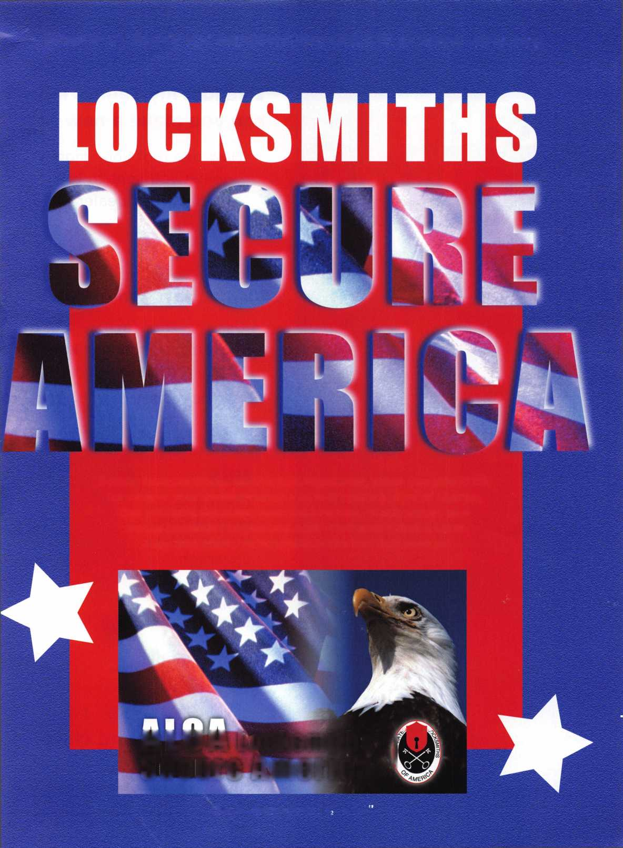

**You're never on your own..**

**Toll Free Tech Support**

**1**-**800**-**342-5080**

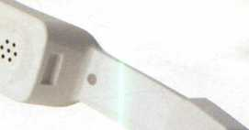

"I've lost my Taurus keys...  
can you make a new set?"

How much of your money

have you sent to the

local Ford dealer?

d

m

W

■

8008LA New Generation STAR

Use the Ford factory tool to  
program transponder keys for  
ALL Ford/Mazda vehicles.

Keep the money in your pocket!

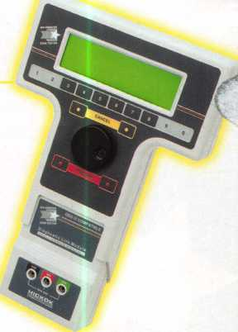

NGS

Complete

Ford/Mazda

transponder

coverage

PLUS the

ability to  
clear ALL  
Diagnostic

Service Codes

Say "YES" to  
$100 phone calls



HICKOK

for more information visit

**[www.hickok-inc.com](http://www.hickok-inc.com)**

INCORPORATED

